**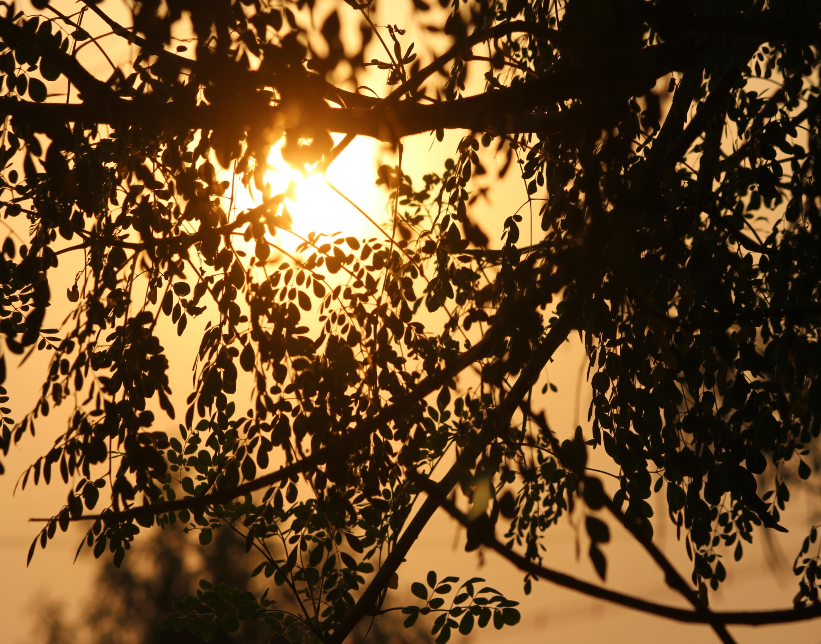**

**Analysis of a Handloom Cluster**

**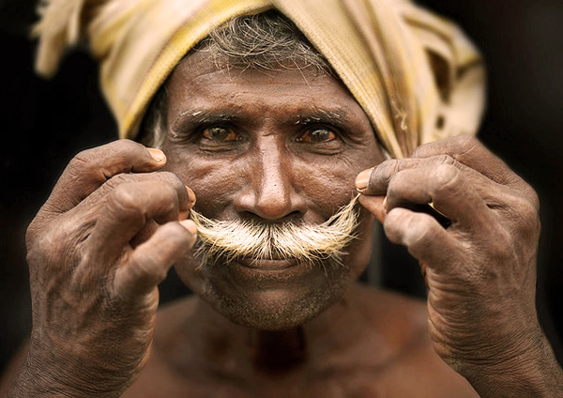**

Submitted By: Aditi Galada

Batch 2016 – 2020

Department of Fashion Technology

NIFT, Chennai

Faculty Mentor: Dr. Divya Satyan,

Associate Professor and CC- MFT,

Department of Fashion Technology,

NIFT, Chennai

*-Aditi Galada, Madhoomitha, Vishnu Priya, Abhinaw Raj, Ambuj Deepak, Sanyam Jain*

Acknowledgement

First, I would like to thank the Almighty God for providing me with the knowledge, strength and wisdom which enabled this project to be completed successfully.

I would like to express my special thanks to my college who gave me the golden opportunity to be a part of this research project.

I am highly indebted to my mentor, Dr. Divya Satyan for her guidance and constant support. Without her leadership this project would not have been successful.

I would also like to express our special gratitude to the community of weavers at Thirumalpur for providing me the required information and their unparalleled co-operation.

Contents

[1. EXECUTIVE SUMMARY 6](#_Toc48493935)

[2. INTRODUCTION 7](#_Toc48493936)

[3. ANALYSIS OF MACRO ENVIRONMENT 12](#_Toc48493937)

[4. TYPES OF WEAVERS 21](#_Toc48493938)

[5. COOPERATIVE SOCIETY 22](#_Toc48493939)

[6. WEAVING COMMUNITY AT SANJEEVRAYAN THERU 24](#_Toc48493940)

[7. SURVEY OF WEAVERS 36](#_Toc48493941)

[8. MAKING THE KANCHEEPURAM SAREE 37](#_Toc48493942)

[9. SPECIALITY OF KANCHEEPURAM SAREE 48](#_Toc48493943)

[10. COSTING 58](#_Toc48493944)

[11. PROBLEMS AND ISSUES FACED BY PEOPLE IN THIRUMALPUR 59](#_Toc48493945)

[12. FINANCIAL AID 61](#_Toc48493946)

[13. SOCIAL CONDITION 62](#_Toc48493947)

[14. SWOT ANALYSIS 64](#_Toc48493948)

[15. FUTURE 66](#_Toc48493949)

[16. CONCLUSION 67](#_Toc48493950)

[17. REFERENCES 68](#_Toc48493951)

[18. ANNEXURE 69](#_Toc48493952)

**Figure Content**

|  |  |  |  |
| --- | --- | --- | --- |
| S.no | Figure name | Figure No. | Page No. |
| 01 | India Map, Map of Tamil Nadu | 1,2 | 10 |
| 02 | Map of Thirumalpur, Satellite map of Thriumalpur | 3,4 | 11 |
| 03 | Temple tank of Manikanteswara Temple | 5 | 12 |
| 04 | Silk Saree, Janatha Cotton Saree, Pillaiyar Towel, Lungi | 6,7,8,9 | 13 |
| 05 | Congress Party Symbol, AIADMK Party Symbol | 10,11 | 15 |
| 06 | Canara Bank | 12 | 16 |
| 07 | A girl in school uniform, Report card | 13,14 | 18 |
| 08 | TV set in a house, Transport Facility:Auto, Transport Facility:Bus | 15,16,17 | 19 |
| 09 | Carved wooden door, Thinnai in a traditional house Kolam outside the house | 18,19,20 | 21 |
| 10 | Home Delivery of products ordered online, House powered by solar electricity | 21,22 | 22 |
| 11 | Heap of garbage, Fabric waste | 23,24 | 23 |
| 12 | Cooperative Society of Thirumalpur | 25 | 25 |
| 13 | Street Model, Sanjeevrayan Theru | 26,27 | 26 |
| 14 | Ladies sitting in the Verandha, Men having lunch together | 27,28 | 27 |
| 15 | Satellite map of sanjeevrayan theru, Sanjeevrayan Theru | 29,30 | 28 |
| 16 | Another store at Thirumalpur, Departmental Store | 31,32 | 29 |
| 17 | Primary School at Thirumaplur | 33 | 30 |
| 18 | Veterinary Hospital at Thirumaplur | 34 | 31 |
| 19 | Shiva temple at the end of street, Lord Ganesha temple in the middle of the street | 35,36 | 32 |
| 20 | Pie chart showing profession of people living in Sanjeevrayan Theru, Pie chart showing the number of people who undertook training Sanjeevrayan Theru | 37,38 | 41 |
| 21 | Pie chart showing products made by people in Sanjeevrayan Theru, Pie chart showing types of weavers in Sanjeevrayan Theru, Pie chart showing types of looms in Sanjeevrayan Theru | 39,40,41 | 42 |
| 22 | Raw silk, Zari Thread, Drying process | 42,43,44 | 43 |
| 23 | Drying process, spinning wheel, shuttle | 45,46,47 | 44 |
| 24 | Warp beam | 48 | 45 |
| 24 | Jacquard loom, Jacquard Handloom | 49,50 | 46 |
| 26 | Punch cards, Bamboo spool | 51,52 | 47 |
| 27 | Dying process | 53 | 48 |
| 28 | Entangles and breaks are cleared in spinning process, Silk is spun to make spindles | 54,55 | 50 |
| 29 | Warp is stretched over bamboo stick to inspect breaks in the silk threads | 56 | 51 |
| 30 | Warp After warping silk is dipped in rice starch, Warp is being reeled to warp beam, Each thread from warp beam is being attached to the loom silk threads | 57,58,59 | 52 |
| 31 | Line diagram of a loom | 60 | 53 |
| 32 | Continuous pedal movement to operate loom | 61 | 55 |
| 33 | Shedding, Picking | 62,63 | 56 |
| 34 | Beating, External Zari thread is inserted to create motif designs.: | 64,65 | 57 |
| 35 | Fell of the cloth | 66 | 58 |
| 36 | (Paisley pattern given to the weavers, Paisley Pattern on a saree | 67,68 | 59 |
| 37 | Annapakshi pattern given to the weavers, Annapakshi Motif on a saree | 69,70 | 60 |
| 38 | Vines pattern given to the weaver, Voluptuous Motif on a saree | 71,72 | 61 |
| 39 | Tree Of Life Motif pattern given to a weaver, Voluptuous Motif on a saree, Lotus pattern given to the weaver | 73,74,75 | 62 |
| 40 | Lotus bud pattern given to the weaver, Lotus bud motif on a saree, Lotus Motif on a saree | 76,77,78 | 63 |
| 41 | Yali sculpture, Yali motif on a saree | 79,80 | 64 |
| 42 | Checks on a saree, Thandavalam on a saree | 81,82 | 65 |
| 43 | Elephant motif on a saree, Peacock’s eye motif on a saree | 83,84 | 66 |
| 44 | Rising Border on a saree, Temple Border on a saree | 85,86 | 67 |
| 45 | Rudraksh Border on a saree, Korvai Technique of making a Kancheepuram saree | 87,88 | 68 |
| 46 | Anatomy of a Kancheepuram saree, Petni of a Kancheepuram saree | 89,90 | 69 |
| 47 | Energy charges | 91 | 70 |
| 48 | Cooking utensils in the house | 92 | 74 |
| 49 | A typical house | 93 | 75 |

# EXECUTIVE SUMMARY

The primary objective of this project is to analyze the conditions of the weavers at Thirumalpur.

This involves a process of gathering, analyzing, and dispensing information for tactical or strategic purposes and obtaining both factual and subjective information on the environments in which the weavers are working.

Ethnographic observation involves embedding oneself deeply and over the long-term in a field site of study to systemically document the everyday lives, behaviors, and interactions of a community of people. As a written product, ethnography is a richly descriptive account of the social life and culture of the group studied. Our visit to Thirumalpur helped us learn about the everyday life, culture, religion and believes of the people living there. The lifestyle followed by people in Thirumalpur is plain and simple. There is no din and bustle of the city. Everything is calm and quiet. People are in direct touch with nature and their close family and friends. Most of their time passes in looking after fields and devoting their lives to the age-old art of weaving. Their days begin and end with the sound of the looms. The people of Thirumalpur are religious, conservative and pious. Everyone follows Hinduism and devote much of their time to prayers.

The study was performed in two sets, one that formed the primary data which was collected by surveying the area, interacting with the locals and the visitors. The other set consists of the information which is gathered about that place through published literature material.

Our area of study was Thirumalpur, a town situated in Nemili Block of Vellore district in Tamil Nadu, India. The weavers of Thirumalpur worked under the government previously before private societies from Kanchipuram who provide raw materials and get labor in exchange for money. Most families in the Thirumalpur have power looms that manufacture cotton- polyester sarees, where cotton is the warp and polyester in the weft, these families get 750 units of power for free from the government.

Our area of study mainly deals with weaving. We started our survey with the data collection of our macro environment, i.e. observing the location, and further interrogated and surveyed the micro-environment. The collection of data and face to face commutative interactions with the people and residents of Thirumalpur helped us to find out not only the functioning of the looms but all the other factors related to the growth, hygiene and several other issues of the place.

# INTRODUCTION

Today we live in a competitive world where there are new inventions and creations everyday but still all these developments concern to certain sector of the people. The weavers at Thirumalpur have not advanced much technologically, this makes it difficult for them to compete with large scale industries.

* 1. **About Thirumalpur**

Thirumalpur is a typical village in Tamil Nadu which was considered as part of Kancheepuram in the history of puranas.  Here there is a temple Manigandeeswarar, which was built about in 1600 B.C.  The Mythology Says that Lord Vishnu wanted to have Sudharsan Chakra from Lord Shiva, so Lord Vishnu performed pooja daily, with 1008 Lotus flowers.  One day while Lord Vishnu was performing pooja with 1008 Lotus, Lord Shiva had concealed one lotus flower from 1008 Lotus flowers so as to test the dedication of Lord Vishnu.  Lord Vishnu found that one Lotus flower was missing from 1008 Lotus, immediately Lord Vishnu offered one of his eyes as 1008th flower and kept at the feet of the Lord Shiva and performed the pooja.  Lord Shiva was very much pleased and blessed Lord Vishnu with required prayer and also declared the place in the name of Lord Vishnu i.e. Thirumal. Since Lord Vishnu got blessing (peru) the place is called Thirumalperu and in due course of time it is being called THIRUMALPUR.

* 1. **Geographical Background**

Thirumalpur is located in the North West border of Vellore district i.e. in between Kancheepuram and Arakkonam (20 kms away from Kancheepuram, 20 kms away from Arakkonam).  Thirumalpur is covered by Pallur in East, Panapakkam in West, Nemili in North and Vathiyur in South.  It is well connected by road from Kancheepuram, Arakkonam and Vathiyur.  Connected by rail from Arakkonam and Kancheepuram.

Nearest Government Hospital          -  Kancheepuram  
District head quarter                        -  Vellore  
Nearest Railway junction                -  Arakkonam

## *C:\Users\aditi\Downloads\image1.jpeg*https://upload.wikimedia.org/wikipedia/commons/thumb/0/04/India_Tamil_Nadu_locator_map.svg/2000px-India_Tamil_Nadu_locator_map.svg.png

*Fig 2 (Map of Tamil Nadu ;Source:* [*http://collections.infocollections.org/ukedu.html*](http://collections.infocollections.org/ukedu/en/d/Jh2379e/5.1.html)*)*

*Fig 1 (India Map ; Source:* [*http://collections.infocollections.org/ukedu/en/d/Jh2379e/5.1.html*](http://collections.infocollections.org/ukedu/en/d/Jh2379e/5.1.html)*)*

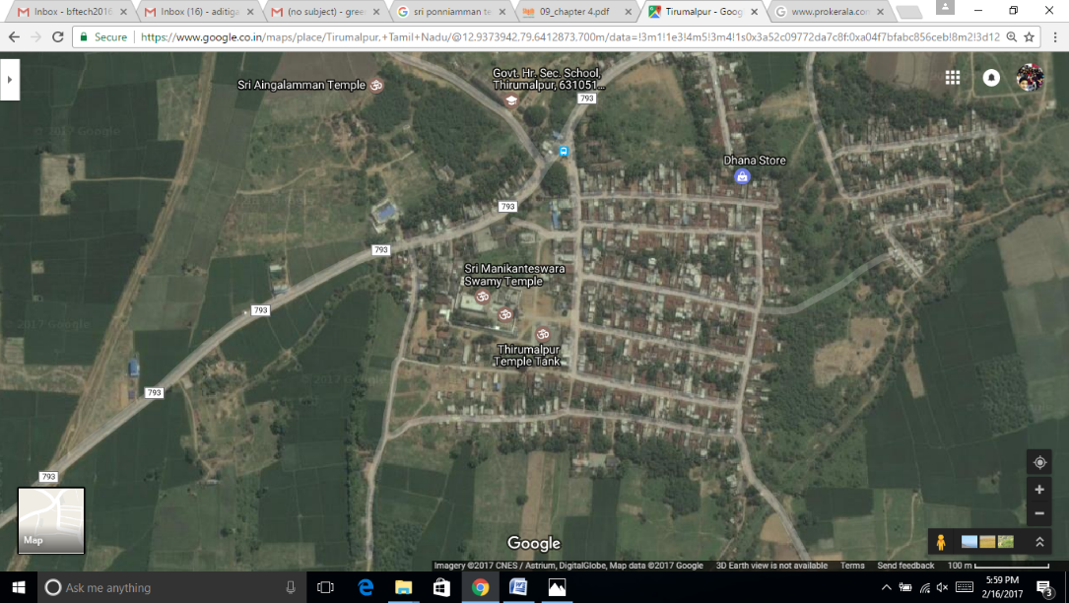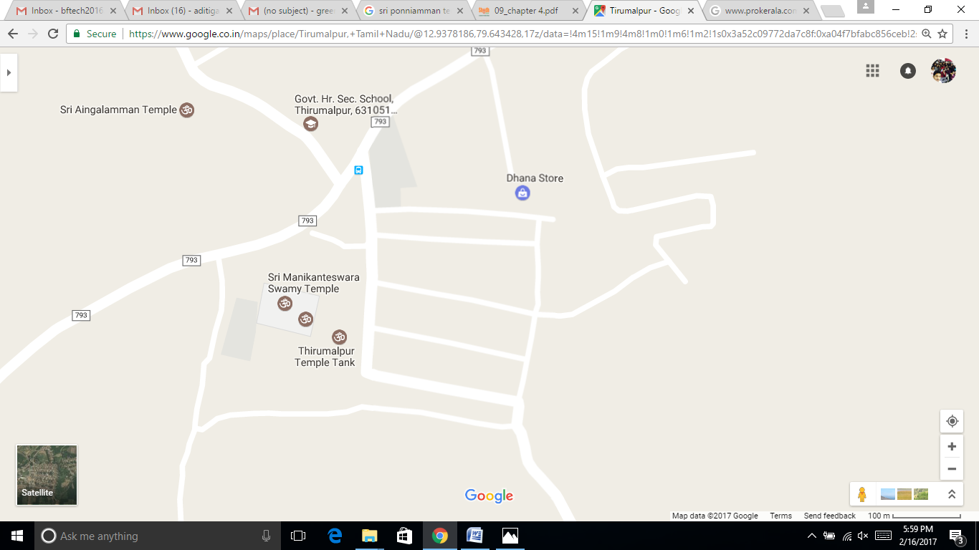

*Fig.4 (Satellite map of Thriumalpur ; source: google images)*

*Fig.3 (Map of Thirumalpur ; source: google images)*

**2.5 Places of Interest at Thirumalpur**

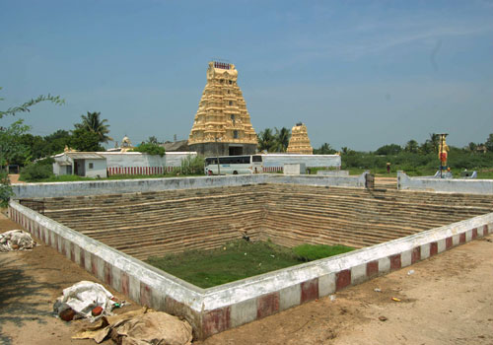Thirumalpur is basically a temple town and has many temples on the streets also. One of the main temples is the Manikanteswara Temple. Everything in the temple signifies unity between Shiva and Vishnu. There was even a statue with the face of Hanuman and the base of Nandhi. The temple was built in the period around 500 BC by Sundara Chozhan. The original Shi-va linga in the temple was actually made of mud and made it through 1500 years! And when the temple was renovated in 2002, a metallic kavasam was clamped on top of the small lingam. Vishnu (called Tirumal) is believed to have worshipped Shiva in this temple and hence the name Thirumalpur. The temple has a four-tiered rajagopuram (temple tower). The temple has set of inscriptions from Chola period of Rajaraja Chola I (985 – 1014 CE). The Nandi (sacred bull of Shiva) is in standing portion in this temple unlike other Shiva temple where Nandi is in sitting posture.The temple tree is Bilva.

*Fig.5 (Temple tank of* Manikanteswara Temple *; source: self)*

* 1. **Products Produced**

|  |  |  |
| --- | --- | --- |
| Image result for Janatha cotton saree  *Fig 6 (Cotton Saree; source: self)* | Property | Description |
| Warp | Cotton |
| Weft | Polyester |
| Length | 5.5m |
| Width | 1.14m |
| Price | Rs. 160 |

1. Cotton Polyester Saree:

Janthar saree is a blend of cotton and polyester. Cotton is used in warp and polyester is used in weft. It does not have designs and motifs except lines along the border and pallu. Various colors are used such as pink, blue, green and yellow. The texture of the saree is soft. The saree is given to the people of Tamil Nadu during the Pongal festival by the government under the “Priceless Saree and Dhoti distribution Scheme”. It is established to benefit the poor and providing higher employment opportunities in the handloom, power loom sector.

|  |  |  |
| --- | --- | --- |
| http://www.handloomcluster-wsc-sz.in/thirumalpur/images/prod_img004.jpg  *Fig 6 (Silk Saree; source: self)* | Property | Description |
| Warp | Silk |
| Weft | Silk |
| Zari | Used for motifs, border & pallu |
| Length | 5.5m + 0.5m (fabric for blouse) |
| Width | 1.14m |
| Price | Rs. 5000 – Rs.50,000 |

1. Silk Saree:

Silk saris are woven in handlooms. They are woven with silk yarns and zari. The patterns and motifs vary with each saree. Bright colors are used. The pallu and border are decorative. The surface of the saree is smooth and shiny.

|  |  |  |
| --- | --- | --- |
| *http://www.handloomcluster-wsc-sz.in/thirumalpur/images/prod_img013.jpg*  *Fig 8 (Pillaiyar Towel; source:self)* | Property | Description |
| Warp | Cotton |
| Weft | Cotton |
| Length | 20 – 40 inches |
| Width | 18 – 20 inches |
| Price | Rs. 15 – Rs. 20 |

1. Pillayar Towel

Pillayar towels are used to drape the shrines in the temple. They are made in handlooms or power looms. They are mostly white in color with lines at the borders. They are made from cotton and the density of the fabric is less.

They are produced in various dimensions such as 20x 20 to 40x 20.

|  |  |  |
| --- | --- | --- |
| http://handloomcluster-wsc-sz.in/thirumalpur/images/prod_img017.jpg  *Fig.9 (Lungi ;source: self)* | Property | Description |
| Warp | Cotton |
| Weft | Cotton |
| Length | 2m |
| Width | 1.15m |
| Design | Madras checks |
| Market rate per product | Rs. 250 – rs. 400 |

1. Lungi

Lungies are fabrics similar to dhoti that has to be draped around the waist. But they are stitched tubular for comfort. “Madras Checks are used on the lungies to create various checked patterns. Cotton is used in both warp and weft. The texture is soft.They are made from either handlooms or power looms.

# Analysis of Macro Environment

**3.1 Political Factors**

DEMONETIZATION: For the first time in Thirumalpur, few weavers collected their wages from the bank. Till earlier they would receive advance wages in cash from the cooperative materials along with materials for every sari they weaved. However, after the government announced that Rs 500 and Rs 1000 notes were no longer legal tender from November 9 2017, their wages for weaving saris were transferred directly to their bank account. The weavers have hardly any savings anyway, so they did not have many notes to exchange. They just needed to withdraw the advance they got, used it to eat and then start to work.

While this was the first time that the weavers received their wages in bank accounts, they were not entirely unfamiliar with banks. They received their yearly bonus in the accounts. They also get loans from government schemes to buy certain weaving equipment parts. But while the production of sarees may not have been significantly impacted by the demonetization, there was a definite downward spike in sales.

### DROP IN SALES**:** 70% of the sales of sarees take place in cash. Many people come with cash that they have saved up for an occasion and buy in bulk. But during the time of demonetization they were hesitant. January being the wedding season their sales during November and December are usually at their peak but because of notes ban they were terribly impacted.

### IMPACT ON PRIVATE BUSINESSES: The weavers said that they had also not been able to obtain the raw materials – zari from Surat, because of the cash crunch.

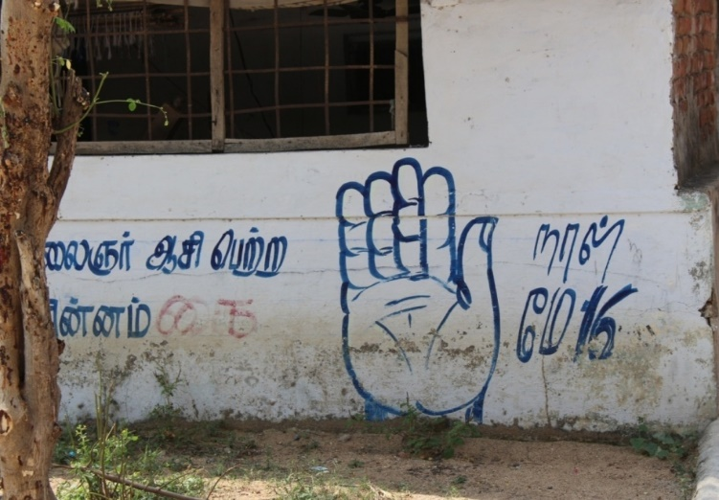 *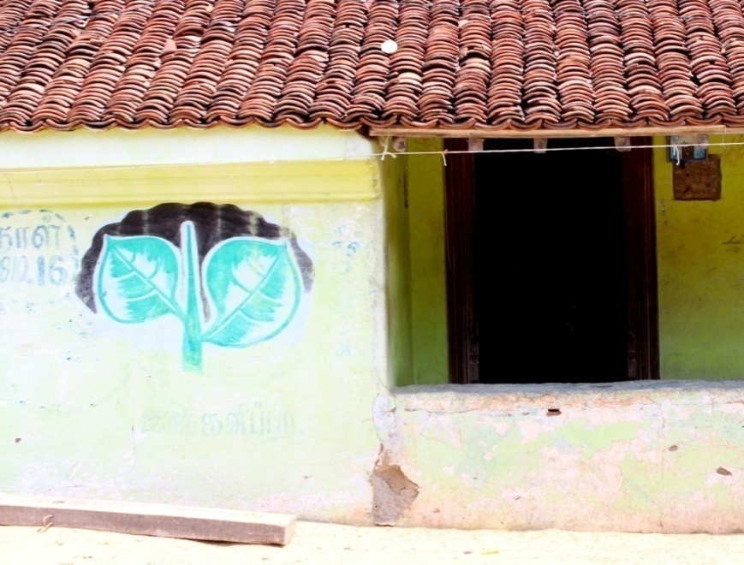*

*Fig.10 (AIADMK and Congress Party Symbols; source:self)*

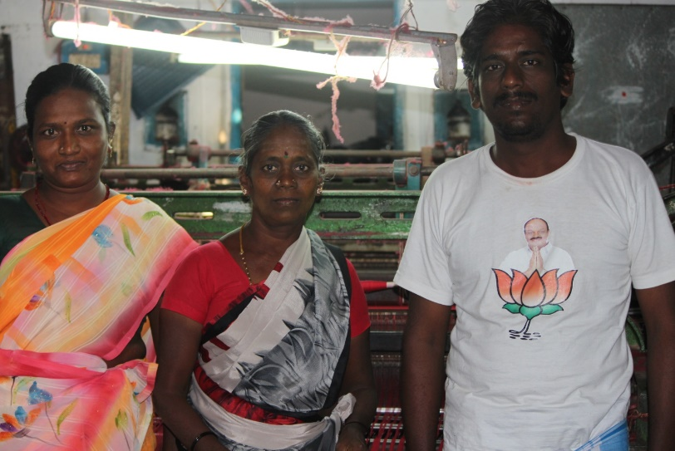

*Fig.10 (Villager wearing a t-shirt provided by party workers ; source:self)*

During election campaigning the Party symbols are painted on house walls and t-shirts with party symbols are distributed. The party workers offer the house owners about 100 rupees to let them paint on their house walls. The villagers let them paint for the money they get in return, but this doesn’t affect the vote they’d cast in any way.

* 1. **Economic Factors**

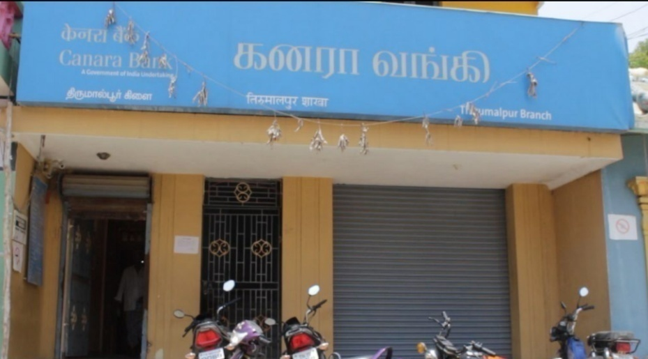Weaving one sari usually takes about 15 days, even more if it involves an elaborate design. Weavers get anywhere between Rs 1,000 to Rs 5,000 for his labor on a sari, which is often sold at double or triple the price in the market. This explains why the economic conditions of weavers in Thirumalpur is poor.

Most of the weaver members involved in silk weaving are illiterates. As they are uneducated, they face many problems in knowing the modern techniques in weaving, in utilizing the welfare schemes of the Government, in getting financial assistance from banks and other similar funding agencies.

School students suffer due to the lack of facilities in the education. There is one government school in the area with an annual fee of Rs. 400 per student. The school had proper infrastructure but lacked on the number of teachers.

*Fig.12 (Canara Bank ; source:Self)*

The sale of the sarees increases during the wedding seasons or festivals. If the weavers own land, they do farming when they don’t get any orders but most of them do not own any agricultural land. The cost of raw material has increased in the past few years and hence their earning has decreased.

There is a bank (canara bank) and India ATM in the village.

There is no shortage in availability of electricity and water. The power is cut only once a month. The government gives 750 units of free power to weavers running power loom and 100 units to weavers working on handloom.

Most of the parents send their children out of the village to work at a private company. Most of them have done engineering and work at VolTech in Banglore. This is improving their economic condition as their children are able to earn much more than they could if they joined the ancestral weaving business.

* 1. **Socio-Cultural Factors**

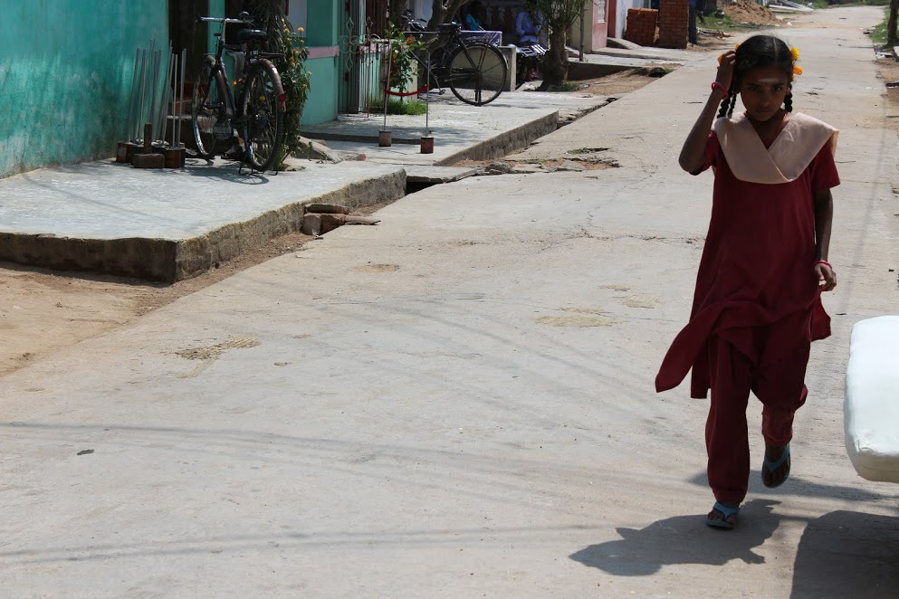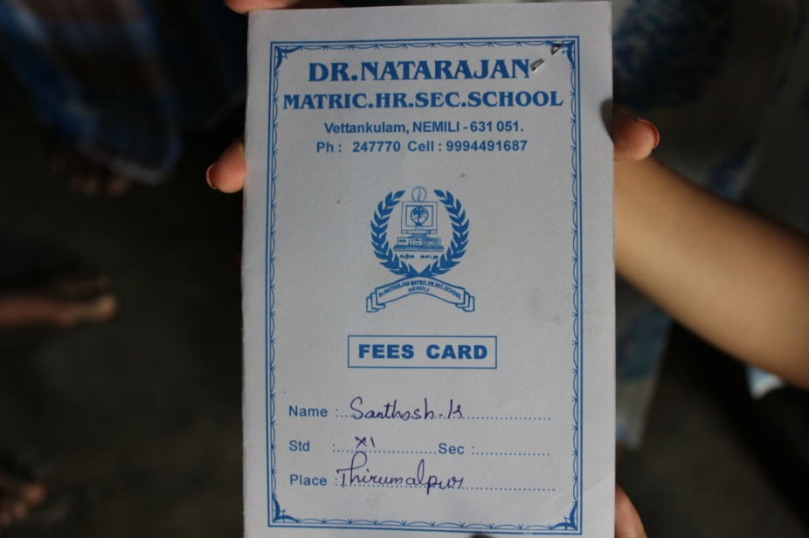The sex ratio at the village is about equal with 2429 males and 2374 females.Most of the adults in the village are illiterate but due to increased awareness about education they send their children to school. There are both government and private schools near the village. The nearest college is 5kms away from Thirumalpur and the parents are willing to send their children to bigger cities for further education and better jobs. They do not expect their children to continue their weaving business.

*Fig.13 (A girl in school uniform ; source:Self)*

*Fig.14 (Report Card ; source:Self)*

**Entertainment facilities:** The nearest cinema theatre is 9kms away**.** Almost all the houses had a TV and the nearest hotel is Hotel Sri Annapoorna Veg Restaurant which is 4.6kms away.

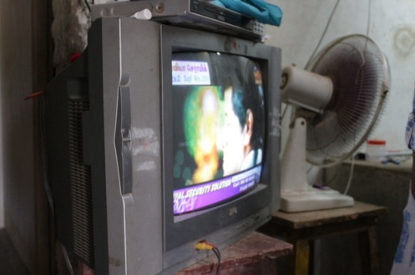

*Fig.15 (TV set in a house; source:Self)*

**Medical Facilities:** Medical facilities are not available in the village. People need to travel to Kancheepuram, Padapakkam or Attapakkam to visit a hospital. The village also lacks health centre, nursing homes and clinics. There are no private medical practitioners either.

**Transport facilities:** Though the village has bus services, which connects the village to nearby towns and villages, the frequency of the buses is less. This poses as a major problem to the residents of the village. Railway services are available from near the village.

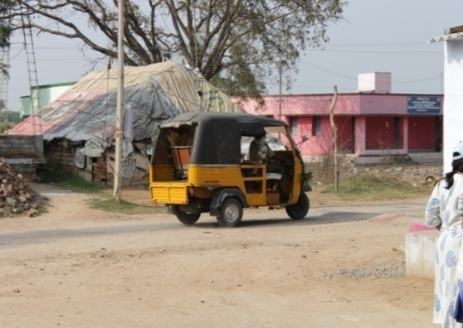 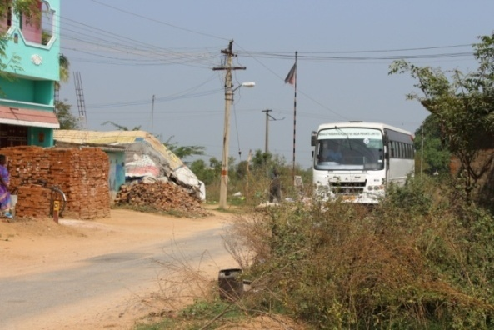

*Fig.17 (Transport Facility:Bus; source:Self)*

*Fig.16 (Transport:Autorickshaw; source:Self)*

**Lifestyle:** Men are seen wearing shirts and dhotis/trousers and women usually wear sarees. Rich Dravidian culture was seen in the village. Majority of the population followed the hindu religion and belonged to the Sengunthar caste and have been living there for generations. Rice is the staple diet. **Sengunthar** or **Kaikolar** is a Tamil community found in the Indian state of Tamil Nadu. The word *Kaikkolar* comes from the words *kai* (hand) and *kol* (shuttle used in looms), *Kaikkolar* also means men with stronger arms. Sengunthar priests are vegetarian, wear the sacred thread, and shave their foreheads in the Brahmanic fashion. But when they are concerned with the sacred locus of the interior, meat eating, blood sacrifice, spirit possession, and the worship of small gods are all prominent. Sengunthars thus follow both a priestly model and a Dravidian tradition.

**Traditional houses:** Each house had a wide verandah out front or one that ran around the house called a *thinnai*where you could relax or socialise away from the heat of the day. Pillars supported the terracotta roof of the *thinnai*. Interestingly enough, while the terracotta is now considered typical, it was a luxury when it first began and only the rich received special permission from royalty to use it. Other families used the more modest thatch roof. The most extravagant piece in any of these houses, which is a feature that survives to this day, is the front door, which is always intricately carved. There were beautiful kolams outside the house too.

*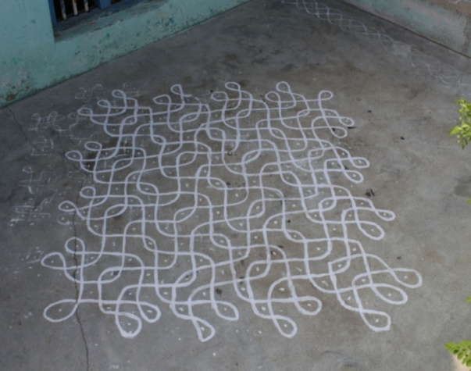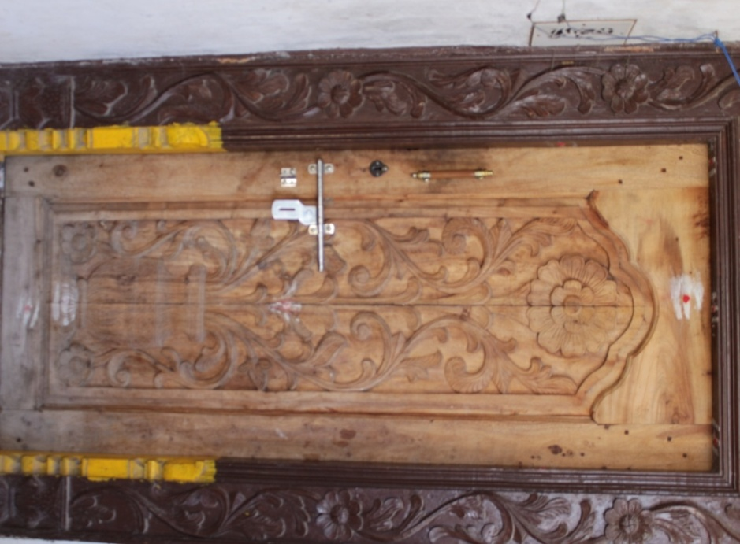*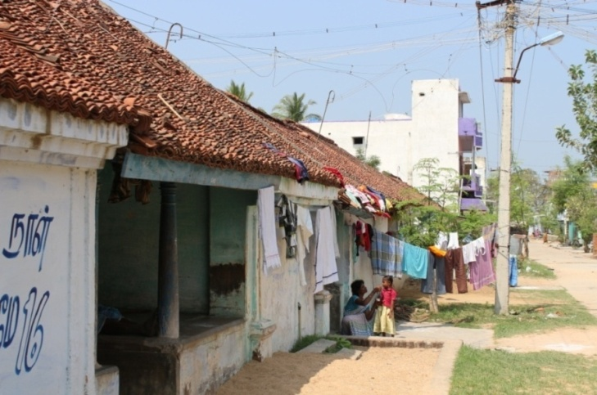

*Fig.20 (Kolam outside a house; source: self)*

*Fig.19 (A traditional house ; source: self)*

*Fig.18 (Carved wooden door ; source: self)*

* 1. **Technological Factors**

During the past two decades, in many silk hand loom clusters, the pit looms used for silk saree weaving have been modernized with many technical developments by dispensing the old techniques used in preparatory, jacquard weaving and designing processes. The main objective of the modernization of hand loom weaving and its related processes, ultimately, is to increase the earnings of the weaver, which is achieved by deriving two advantages namely 1) value addition to the products and 2) increasing the productivity.

Strength of the handlooms stays with weaving intricate silk sarees having more weft way intricacy for which highest skill of the weavers and complete modernization of hand looms with multiple jacquards are required.

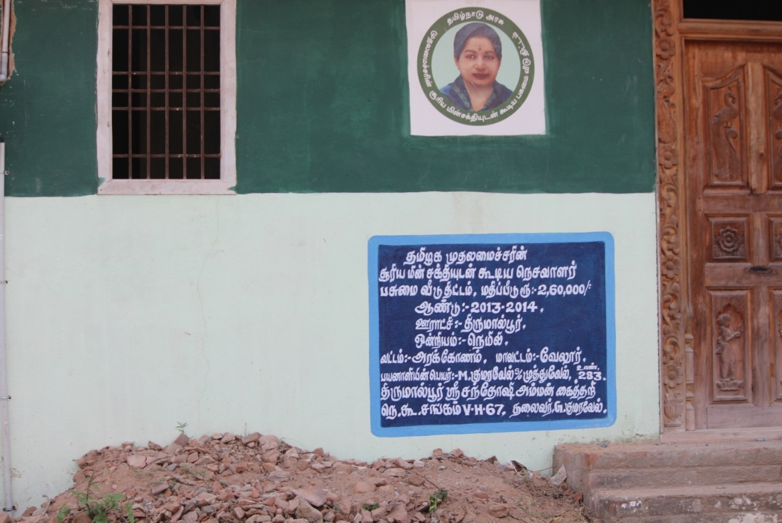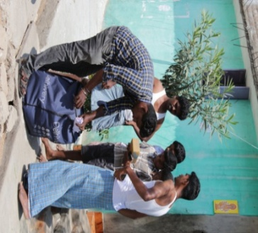The houses which the government has built for the villagers incorporate solar panels. Villagers order products from Flipkart, Amazon and most of the other e-commerce websites frequently because of lack of retail stores and this clearly shows technology has come a long way even in the villages.

*Fig.21 (Home Delivery of products; source: self)*

*Fig.22 (House powered by solar electricity; source: self)*

* 1. **Legal analysis**

In India, the basic exemption limit is Rs. 2,50,000 for a year which is approximately Rs.20,000 per month considering they earn the same amount every month. People who don’t earn above this limit cannot be expected to pay tax. The weavers in Thirumalpur earn much lesser than this limit, most of them earn nearly 10,000 a month.

In 2005, the Government of Tamil Nadu applied for Geographical Indication for Kanchipuram sarees. The Government of India recognized it as a Geographical indication officially since the year 2005-06.

**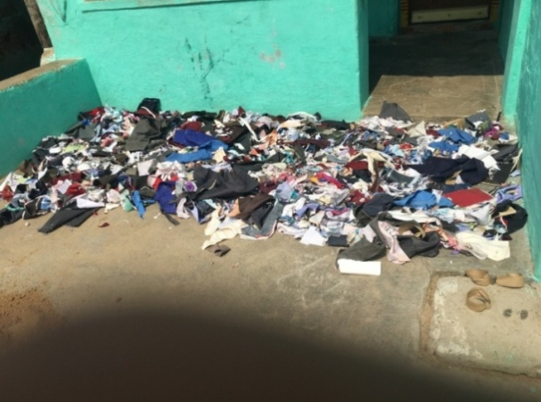**

* 1. **Environmental Factors**

The village receives south west and north east monsoon. The weavers face a problem during weaving during monsoon because the humidity increases which inturn affects the tensile strength of silk yarn whereas in summer there are no such problems faced. Heavy rains during monsoon result in power cuts. During the cyclone Vardha there was a powercut for 3 days.

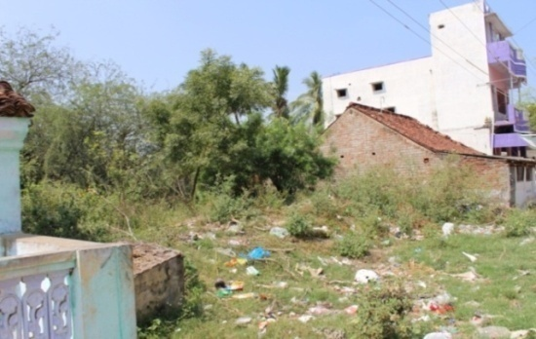Most of the textile machineries cause noise and sound pollution.  
Over-usage of natural resources like plants, water, etc depletes or disturbs ecological balance.  
Silk weaving exhausts water and Petroleum. Using power loom consumes natural resources which will get exhausted soon.

*Fig.24 (Fabric waste;source:self)*

Keeping all this in mind, the traditional way of weaving the Kancheepuram saree does not harm the environment at all. Natural dyes and handlooms were used.

*Fig.23 (Heap of garbage; source:self)*

# TYPES OF WEAVERS

**Independent Weavers:** These have their own looms and work by themselves. They are free to sell their goods as they please. More often than not they have verbal contracts with saree merchants in big towns to weave for them.

**Kuuli Weavers:** People who work on their looms for a wage. These could be from a traditional weaving caste or from other groups who have learnt the skill.

**Shed Workers:** Similar to Kuuli workers. Weavers who work in a shed on looms owned by a master weaver for a wage.

**Big men**: These are weavers or other entrepreneurs who have succeeded in acquiring a saree business big enough to command a number of looms, both their own and contracted looms. The common terminology for them is “master weaver”.

**Co-operative society members**- with the development of co-operative societies in some towns, weavers could belong to one of them and supply sarees to be sold through them.

# COOPERATIVE SOCIETY

A co-operative society is a voluntary association started with the aim of service of its members. It is a form of business where individuals belonging to the same class join their hands for the promotion of their common goals. These are generally formed by the poor people or weaker section people in the society. It reflects the desire of the poor people to stand on their own legs or own merit.

In Thirumalpur many weavers are a part of the Sri Santoshi Amman Cotton and Silk Handloom Weavers Co-operative Production and Sales Society Limited which was started 15 years ago. To join this cooperative society a weaver has to make a one-time payment of Rs. 110.

Sri Santhoshi Amman Cotton And Silk Handloom Weaver's Cooperative Production And Sales Society Ltd is associated with the Tamil Nadu Handloom Weavers' Cooperative Society, popularly known as Co-optex, a cooperative of traditional handloom weavers of the Indian state of Tamil Nadu. This is under the control of Department of Handlooms, Handicrafts, Textiles and Khadi (Tamil Nadu) of Government of Tamil Nadu. The organisation owns a number of shopping outlets in Tamil Nadu. Co-Optex also has an international arm, Co-optex International which exports its products to Germany, France, Netherlands, Belgium, Spain, Switzerland, Canada, Greece, Hong Kong, U.K. South Africa and the U.A.E.   
The co-operative society provides the weavers orders for sarees along with raw materials and buys the sarees from them. The only problem being the sale of sarees is less from January to May and hence the weavers are given lesser orders as there is not enough storage.

The weavers who are a part of the co-operative society also get loans at subsidized rates. The society gave 95 free jacquard machines and 238 accessories so that they can weave more complicated sarees and upgrade their machines to the latest technology which could help them earn more money.

In order to increase the skill of the weavers the co-operative society gave training, which was open to all the people in Thirumalpur, not only the members of the co-operative society. The weavers attended a month training program in which they were taught designing, dyeing, and weaving in 4 batches each of 20 weavers.

The members were also taken on a tour to Salem to give them exposure to other successful Handloom Cluster for trust building and capacity building in the minds of the weavers.

The cooperative society has also tried to do something different for the weavers by making them weave dupattas apart from the traditional products.

It is a fact that the more complex the Kancheepuram saree is the more costly it’ll be but at co-optex they sell sarees between the price range of Rs.3000 – Rs.4000 only. This is because they are able to provide the weavers with almost the same profit only even if they make costlier sarees because it takes more time to weave them.

Once a member has crossed the age of 60 he is given Rs.1000 per month and for the education of children members are given Rs.600 per year. 200 Watt of free electricity is given to each member.

The cooperative society gets a profit of 12% on each product which it uses to raise the living standards of weavers and buying raw materials.

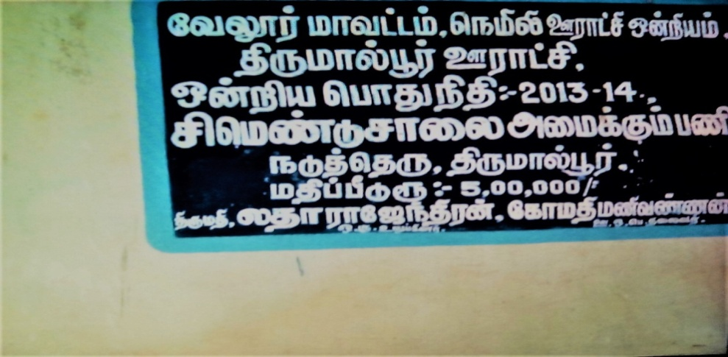

*Fig 25 (Cooperative Society of Thirumalpur, source : self)*

# WEAVING COMMUNITY AT SANJEEVRAYAN THERU

* 1. **Introduction**

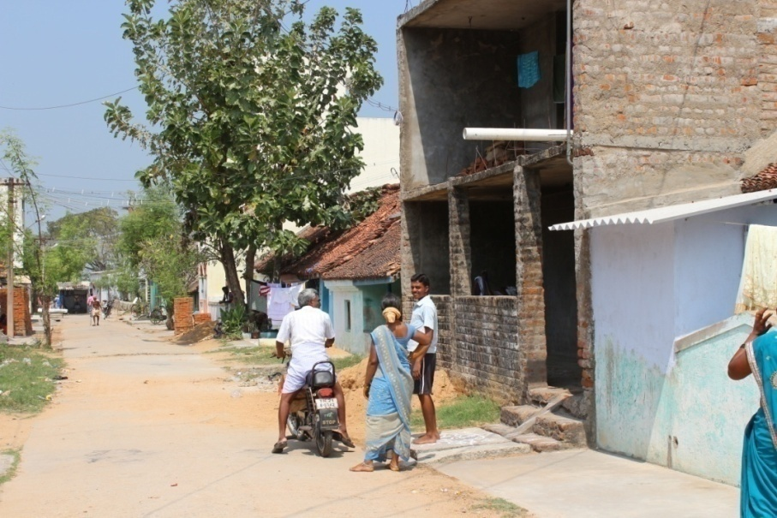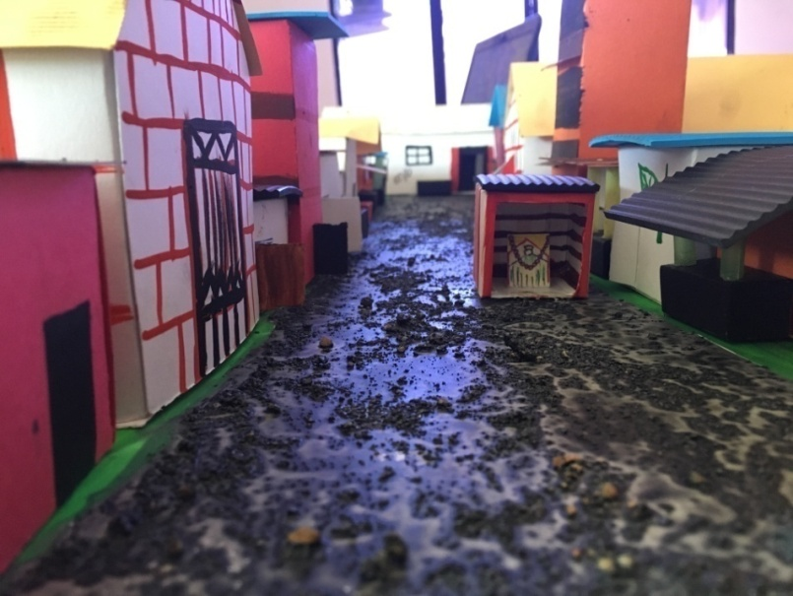Sanjeevrayan Theru, also called the street of silk saree weavers, is a street with almost all its people in the weaving profession and weaving silk sarees.

*Fig.27 (Sanjeevrayan Theru ;source:self)*

*Fig.26 ( Street Model; Source:self)*

There are about 30 houses in the street living like together as if one family. They sit together and eat in the verandhas outside their houses, an integral part of Indian culture but lost in today’s world.

*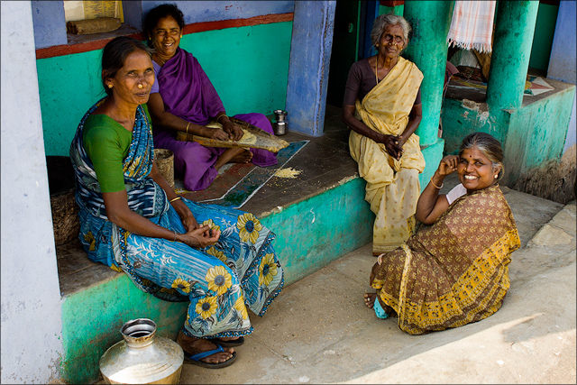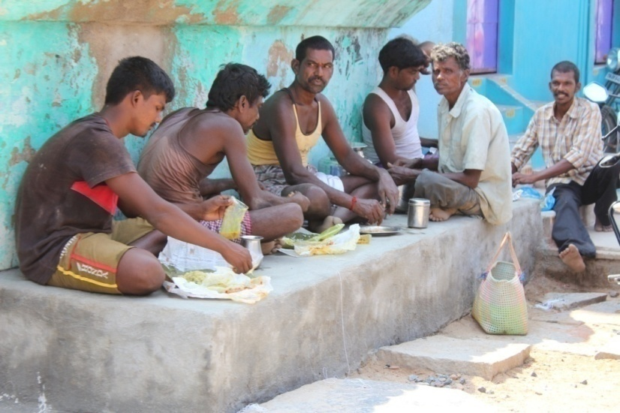*

*Fig.28 (Men having lunch together; source:self)*

*Fig.27 (Ladies sitting in the Verandha; source:self)*

A beautiful street with buildings painted with bright colours and terracotta is very welcoming. The people here have a sense of faith in god and this clearly seen by the number of temples in the street. They have made their own temple by keeping an idol under a thatched roof in the middle of the street.

* 1. **Map**

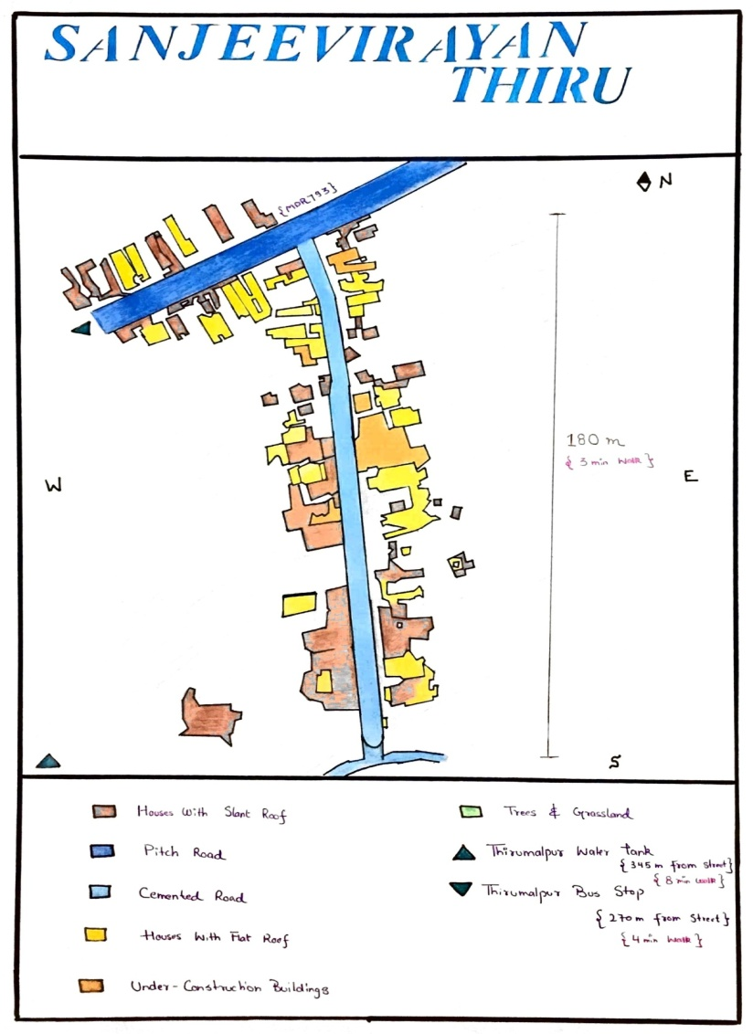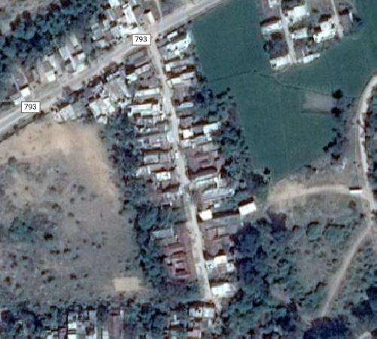

Fig 30 *(Sanjeevrayan Theru;source:self)*

*Fig.29( Satellite map of sanjeevrayan theru; source: self*

* 1. **Places of Interest Near Sanjeevrayan Theru**
     1. 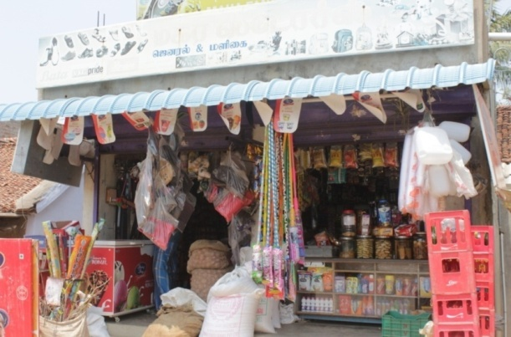**Departmental Store**

The departmental store was run by the men of the family. We had the opportunity to speak to Mr. Mahalinga who was one of the sons running the store. Their family had two stores in Thirumalpur. They were living in Sanjeevrayan Theru before which they lived near Pooniamal Koil.

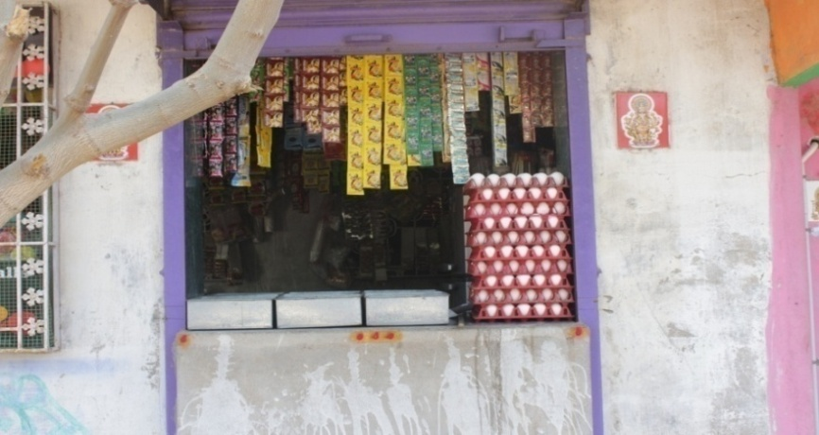The store had a large variety of items including shoes, bags, grocery, toys, lunchbox, belts, tumblers, mugs, brooms, mops and so on. Their supplier was in Kancheepuram and they went there to buy their stock. They usually sell stock worth Rs3000 daily and get a 10% profit. He did wish to expand his business by entering the whole sale market but did not have the opportunity to do so.

*Fig.32 (Departmental Store; source:self)*

* + 1. **General Goods Store store**

This store did not have any name. They sold a few good such as eggs, cold drinks and fruits. It was run by Kuppamma and her son. Even they bought their goods from Kancheepuram and sold it in Thirumalpur. They did not have steady sales.

*Fig.31 (General Goods Store; source:self)*

* + 1. **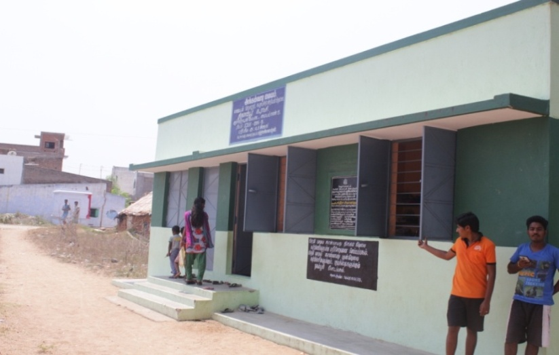Primary School**

This government school had been running for the past 5 years and had 15 students in an age group between 6 months to 5 years. The student are taught classical tamil songs, exercises and were made more intellectual in this primary school. There was one teacher, Koomgodi who was educated upto 10th grade.

**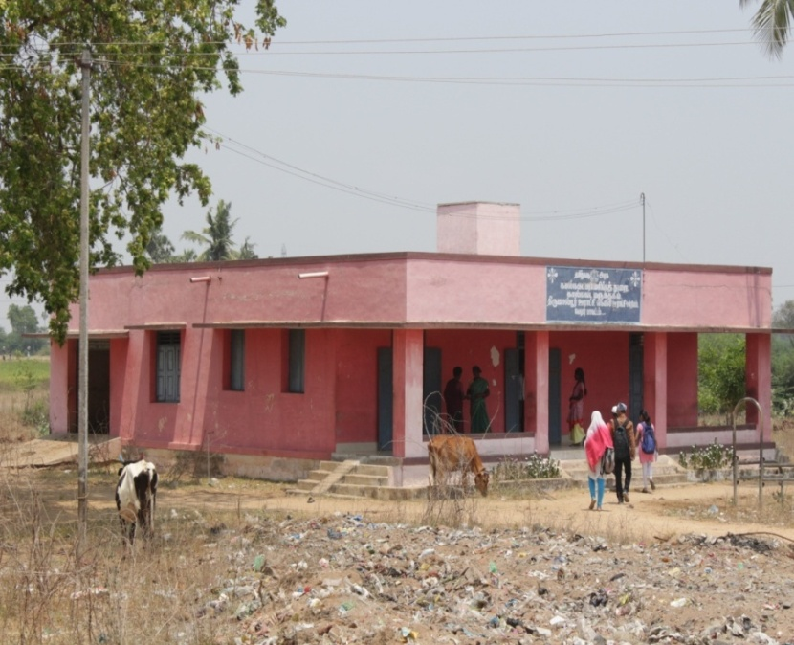**The children were provided with lunch like daal, tomato rice with egg and lemon rice. They even provided pregnant women with 160 grams porridge as it gave them strength. After the child turns 5 years old they are put in government school or private school depending on the financial state of the family.

*Fig.33 (Primary School at Thirumaplur;source:self)*

* + 1. **Veterinary Hospital**

The veterinary hospital was run by the government in 1983 and treatment was provided free of cost. It came under the Vellor district. The doctor we spoke to was Mr. Suresh. There was another doctor Katapadu who gave regular visits but did not stay full time. There were a total of 20 cows whom they took care of.

Treatment was provided for dogs (rabies), cows (fertility), goats, sheep, and chickens too.

*Fig.34 (Veterinary Hospital at Thirumaplur ;source:self)*

* + 1. **Temples**

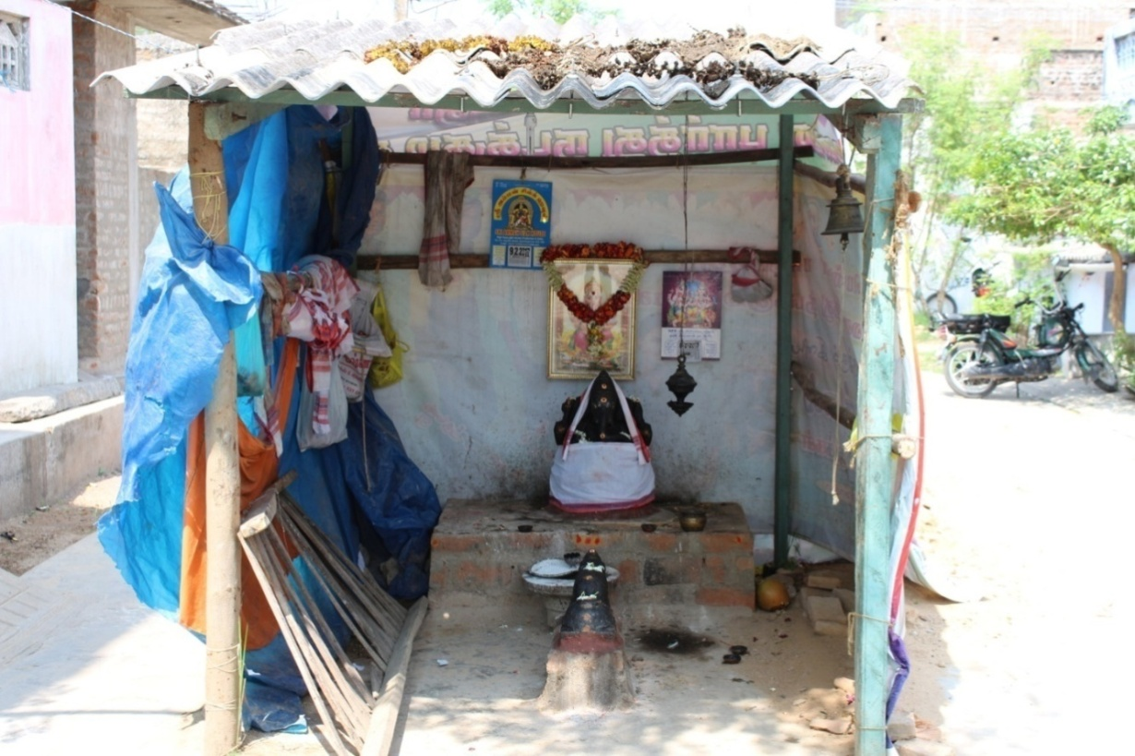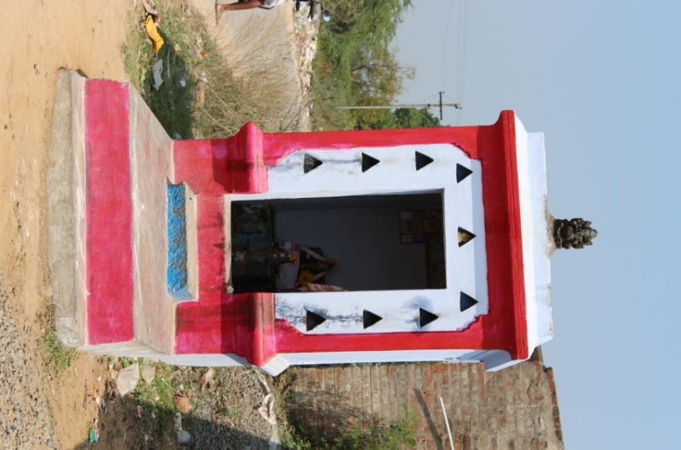

*Fig.35 (Shiva Temple ; source: self)*

## *Fig.36 (Lord Ganesha temple; source:self)*

|  |  |  |  |  |  |  |  |  |  |  |  |  |  |
| --- | --- | --- | --- | --- | --- | --- | --- | --- | --- | --- | --- | --- | --- |
| S. no. | Name | Photo | Working Under | Age | Religion | Member in family | Years  of experience | Type of loom | Training | Bank Loan | Qualification | Profit(inRs./no of items) | Products |
|  | Desigan | IMG_6159.JPG | Co-operative Society | 65 | Hindu | 2 | 35 | Handloom : Dobby | No | No | 3rd | 50/1 | Lungi |
|  | Kumar | C:\Users\aditi\Desktop\New folder\IMG_7064.JPG | Independent | 39 | Hindu | 3 | 20 | Handloom: Jacquard | Yes | No | 10th | 24000/3 | Silk saree |
|  | Pandian | C:\Users\aditi\Desktop\New folder\IMG_7065.JPG | Kuuli | 55 | Hindu | 5 | 30 | Handloom: Jacquard | No | No | 10th | 15000/3 | Silk saree |
|  | Jagadish | C:\Users\aditi\Desktop\New folder\IMG_7066.JPG | Kuuli | 58 | Hindu | 2 | 30 | Handloom: Jacquard | Yes | 50,000 | 8th | 10000/3 | Silk saree |
|  | Jeevan | C:\Users\aditi\Desktop\New folder\IMG_7067.JPG | Kuuli | 38 | Hindu | 4 | 15 | Handloom: Jacquard | Yes | No | 7th | 12000/3 | Silk saree |
|  | Kumari | C:\Users\aditi\Desktop\New folder\IMG_7068.JPG | Kuuli | 45 | Hindu | 4 | 26 | Powerloom: Jacquard | Yes | 25000 | 5th | 10000/3 | Silk saree |
|  | Bhabhati | C:\Users\aditi\Desktop\New folder\IMG_7069.JPG | Cooperative | 35 | Hindu | 5 | 15 | Handloom: Jacquard | Yes | 20,000 | 6th | 10,000/3 | Silk saree, Cotton saree |
|  | Jay Ram | C:\Users\aditi\Desktop\New folder\IMG_7071.JPG | Independent | 38 | Hindu | 5 | 15 | Handloom: Jacquard | No | No | 6th | 18,000/3 | Silk saree |
|  | Loga | C:\Users\aditi\Desktop\New folder\IMG_7072.JPG | Kuuli | 26 | Hindu | 3 | 15 | Handloom: Jacquard | No | No | 3rd | 13000/3 | Silk saree |
|  | Yembabu | C:\Users\aditi\Desktop\New folder\IMG_7076.JPG | Cooperative Society | 45 | Hindu | 5 | 30 | Handloom:  Dobby | Yes | 25,000 | 7th | 55/1 | Lungi |
|  | Karthikeray | C:\Users\aditi\Desktop\New folder\IMG_7078.JPG | Kuuli | 47 | Hindu | 3 | 30 | Handloom: Jacquard | Yes | No | 3rd | 13000/3 | Silk saree |
|  | Meghala | C:\Users\aditi\Desktop\New folder\IMG_7080.JPG | Kuuli | 30 | Hindu | 4 | 15 | Handloom: Dobby | Yes | No | 5th | 12000/3 | Silk saree |
|  | Senthilvarayan | C:\Users\aditi\Desktop\New folder\IMG_7100.JPG | Kuuli | 28 | Hindu | 3 | 15 | Handloom: Jacquard | No | No | 3rd | 7000/1 | Silk saree |
|  | Elangu | Image result for KANCHEEPURAM WEAVERS | Cooperative | 50 | Hindu | 2 | 30 | Handloom: Jacquard | Yes | 25000 | 2nd | 10000/3 | Silk saree, Cotton Saree |
|  | Satish | Image result for KANCHEEPURAM WEAVERS | Cooperative | 47 | Hindu | 4 | 20 | Handloom:  Dobby | No | 10000 | 5th | 7000/3 | Silk saree, Cotton Saree |
|  | Murugan | Image result for KANCHEEPURAM WEAVERS | Kuuli | 30 | Hindu | 5 | 10 | Handloom: Jacquard | Yes | 50000 | 7th | 12000/3 | Silk saree |

# SURVEY OF WEAVERS

## Fig.37 (Profession; source:self)

## Fig.38 (Training; source:self)

## Fig.40 (Types of weavers; source:self)

## Fig.41 (Types of looms source:self)

## Fig.39 (Products made; source:self)

# C:\Users\aditi\Downloads\IMG_6284 (1).JPGMAKING THE KANCHEEPURAM SAREE

* 1. **Tools and Raw Materials**

**Silk:**

The basic raw material used for the production of saris is silk. Finely processed silk is bought from Kancheepuram which is sourced from Karnataka. The tough silk which comes from Karnataka grants luster and smooth finish to the Kancheepuram sari. The silk is first bought in the raw form which is off white in colour.

*Fig.42(raw silk; source- self)*

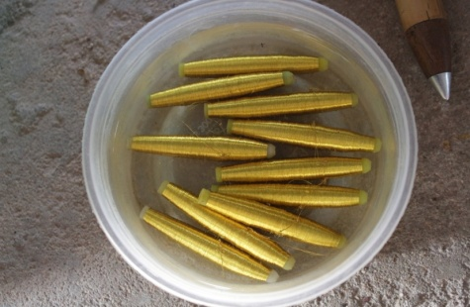**Zari:**

Zari is a tread used to create intricate patterns and motifs on the silk saree. It is traditionally made out of fine gold or silver. Silver treads are electroplated with gold to produce gold Zari. It is sourced from Surat.

Recently, the artisans have started using Zari made of brass. This thread is especially used for borders and pallu of sari

*Fig. 43 (Zari; Source: self*

**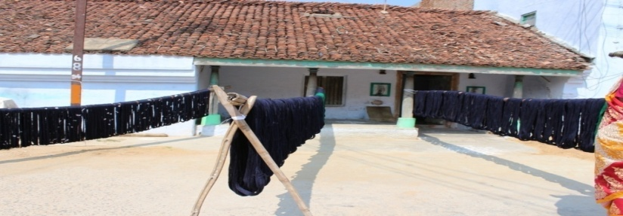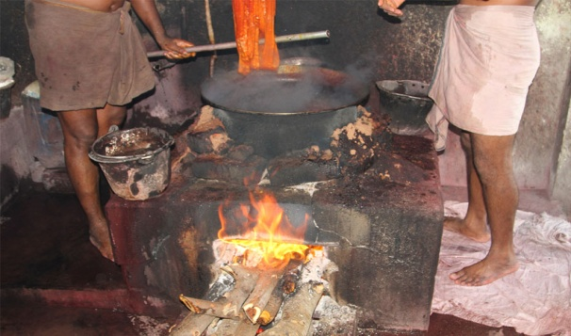Dye Color: Today, the art of dyeing creates such nuances of colour, so delicate in their shades, so subtle in their differences, that no more are the traditional primary and secondary colours are the only choice in a Kanchipuram silk saree. The raw silk has to be degummed of the sericin first before it can take the dye.Dyeing is still done by hand in the cottage industries of Kanchipuram, but mechanisation is fast catching up. The raw silk is dipped in the required colour and then dried.**

*Fig.45 (Dyeing process: source-Internet)*

*Fig.44 (Drying process: source-self)*

**Rice Starch:**  
Starch is extracted by boiling rice. The ladies of the house hold keep extracting the excess water used for cooking rice everyday. The starch gets accumulated in the solution. When the solution starts to smell sour it is ready for use. The extracted solution is locally called as Kanji. Yarn is dipped in the kanji to obtain stiffness.

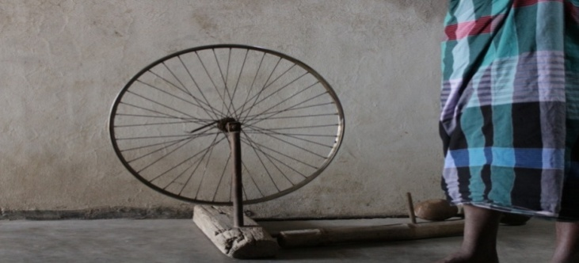

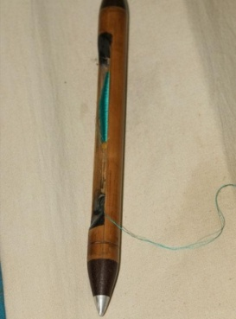**Spinning Wheel:**  
This is a hand cranking spinning wheel which is locally called as ‘Mara Ratinam’. This is done on a home grown reeling system, often using a bicycle wheel. The bobbins were at one time made of DarbaKutchi- the thick stem of the darba grass. Today they have been replaced by plastic bobbins. These spindles are used in weaving process for weft weaving.

*Fig. 47 (shuttle: source-self)*

*Fig.46 (spinning wheel: source-self)*

**Fly-shuttle:**

It is mainly used to process the weft. The spools are inserted in fly-shuttle while weaving. These shuttles are made of whole bamboo pole.

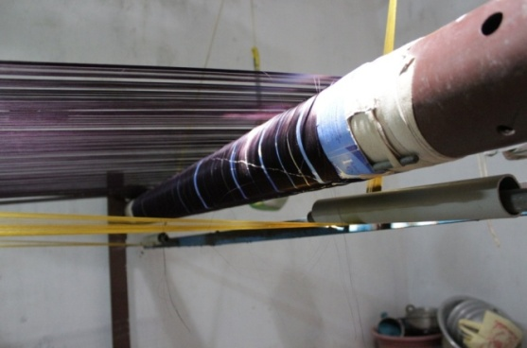

**Warp Beam:**  
The length of yarn is wound on warp beam which is later loaded into the loom. When the warp yarn is mounted on the loom it is tied to a cloth beam (called padamaram) at one end of the loom and then stretched across to the other end to another beam, the oothukattai. The distance between the two beams is usually 12 feet

*Fig.48 (warp beam: source-self)*

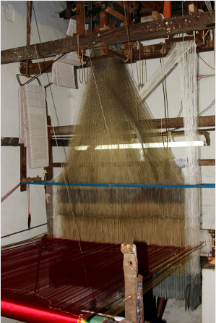

**Jacquard Machine:**  
The loom is controlled by a "chain of cards", a number of punched cards, laced together into a continuous sequence. Multiple rows of holes is punched on each card, with one complete card corresponding to one row of the design. Each position in the card corresponds to a "Bolus" hook, which can either be raised or stopped dependent on whether the hole is punched out of the card or the card is solid. The hook raises or lowers the harness, which carries and guides the [warp](https://en.wikipedia.org/wiki/Warp_(weaving)) thread so that the [weft](https://en.wikipedia.org/wiki/Weft) will either lie above or below it. The sequence of raised and lowered threads is what creates the pattern. Each hook can be connected to a number of threads, allowing more than one repeat of a pattern.

Fig: 49 (Jacquard loom; source: self)

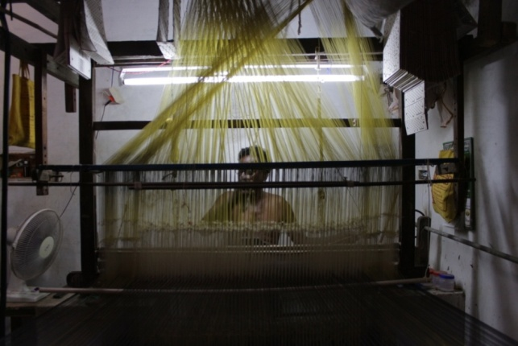

**Handloom:**  
A handloom, is any loom that is manually operated, unlike motorized or electrically powered looms. It is an apparatus on which weavers create fabric by interlacing the warp and weft threads. By providing tension on the warp threads, a hand loom enables the weaver to create cloth quicker and results in a more even weave. There are numerous types of hand looms, from simple, portable backstrap looms to complicated, room-sized jacquard looms.

*Fig.50 (Jacquard Handloom: source-self)*

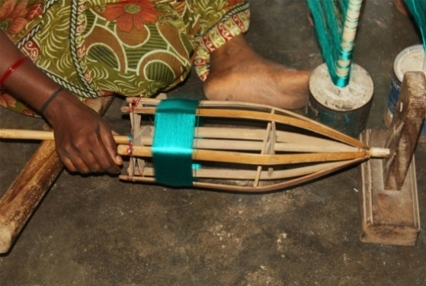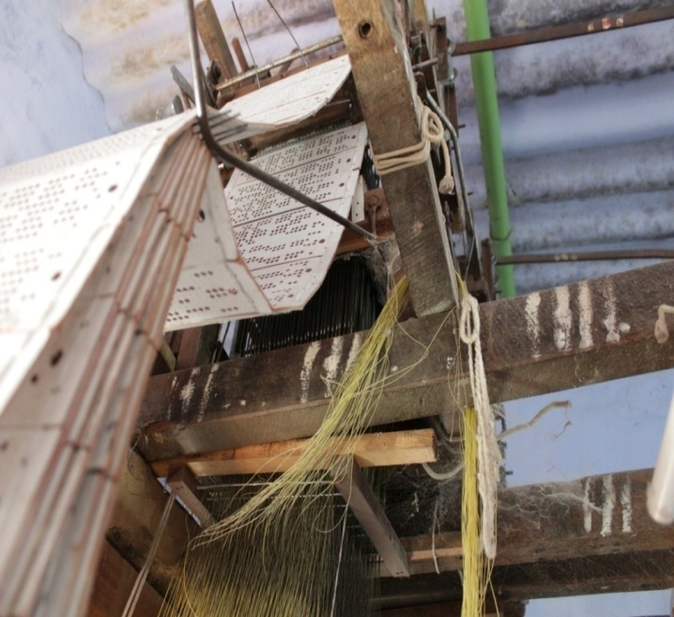

**Punch Cards:**  
The design is punched on the punch cards. The cards are loaded into jacquard machine.

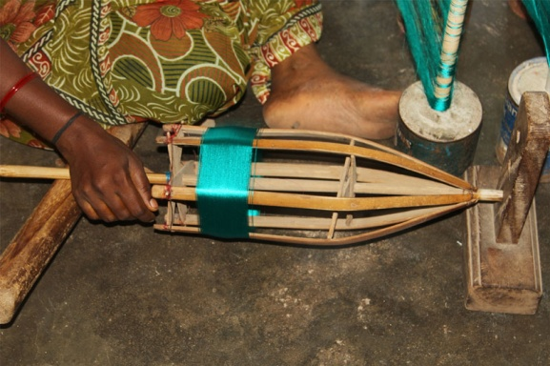**Parivattam:**  
Bamboo spool used to wind the yarn to form silk bundles.

*Fig.52 (Bamboo spool: source-self)*

*Fig.51 (Punch cards: source-self)*

* 1. **Dyeing Process**

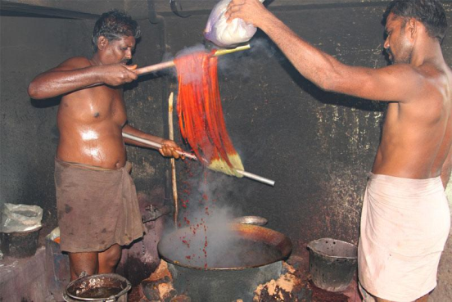

The length of raw silk is first divided in to 3 segments using rubber tube to make 3-saris. Hence these silk segments are colored separately as per the requirements. The border and pallu of a silk saree are dyed in single color. But the body of the sari is dyed in contrast color of border and pallu.  
  
To start dyeing process, water is boiled in a huge copper container. Once water is boiled at high temperature, the dye materials–washing soda, soap oil, dye color are added to the boiling water. The off-white silk yarn is dipped into the colored boiling solution. After dyeing, the colored yarn is immersed normal water to remove excess color. The yarn is taken out from the container and it is allowed to dry for 2 to 3 days. Red, green, blue, and mustard are the popular colors used in dyeing process.

*Fig.53 (Dying process: source-google)*

Dyeing is not done in Sanjeevarayan Theru but some weavers in other streets practice dyeing while others give to people who dye yarns in Kancheepuram.

* 1. **Preparatory Process**

* + 1. **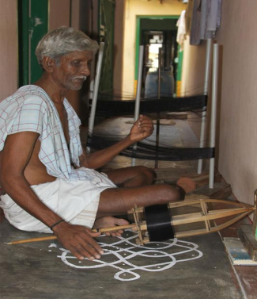Weft Yarn Preparation**

The yarn bundle is first spun onto a traditional bamboo spool locally called as Parivattam. Then, the yarn from these spools is again spun onto spindles with the help of spinning wheel. Silk strand is reeled to spindle and the spinning wheel is operated. The yarn from bamboo spool is transferred into spindles. These spindles are used to insert into fly-shuttle which is used while weaving to weave the weft. The spinning process is done to avoid entangles in the yarn and to ensure the easy weaving.

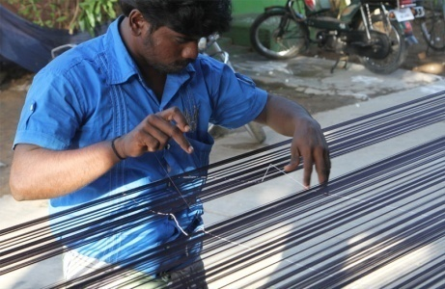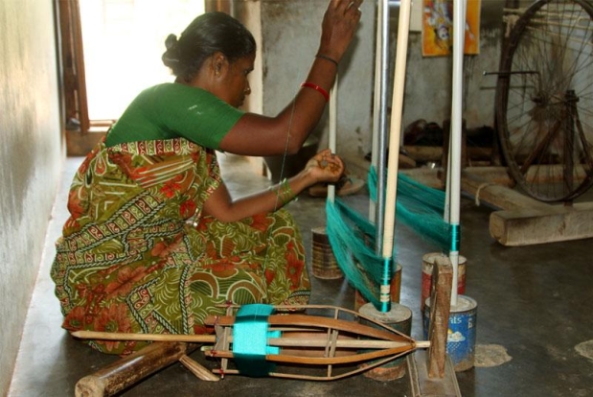 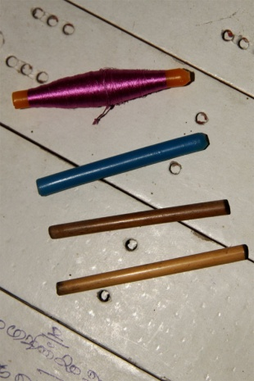

*Fig. 55 (Silk is spun to make spindles: source-self)*

*Fig.56 (Warp is stretched over bamboo stick to inspect breaks in the silk threads: source-self)*

*Fig.54 (Entangles and breaks are cleared in spinning process: source-self)*

* + 1. **Warp Yarn Preparation**

The warping is carried out in streets preferably in the early morning, so that the color of the silk yarn would not be sun-bleached. The length of the yarn is tied between the two poles and the warp is stretched. Entangles in the yarn are checked and then knotted. A cotton thread is laced into the warp as it helps to trace the entangled silk threads. Once the warping is completed, the yarn is dipped in rice starch solution-Kanji to obtain more shine, luster. The yarn is loaded to the warp beam. This is loaded into loom to start weaving process. The length of the warp 18 meters which can make three saris of 6 meters each. Nearly 3 to 5 artisans required to complete warping process.

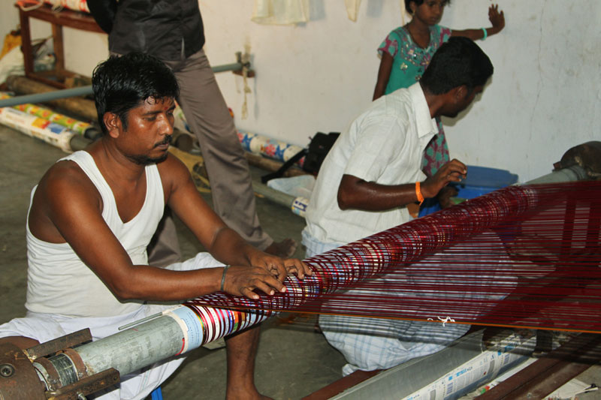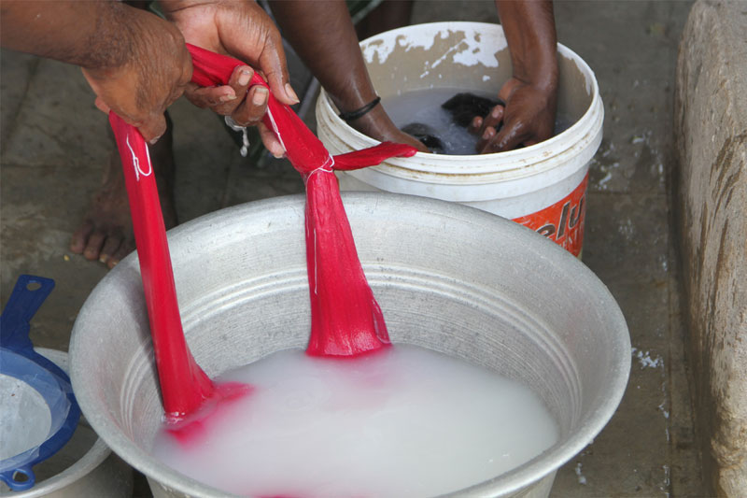

*Fig. 58 (Warp is being reeled to warp beam: source-self)*

*Fig.57 (Warp After warping silk is dipped in rice starch: source-self)*

* + 1. 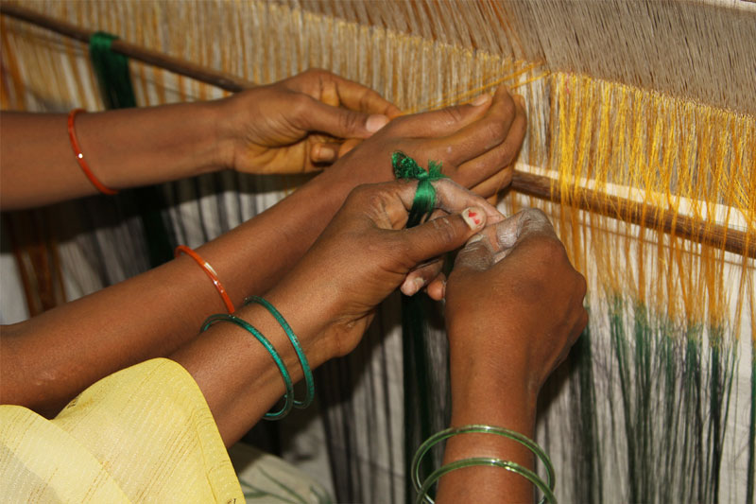**Looming**

The yarn after warping is prepared into warp sheets by rolling the length of yarn to an iron rod. The process of transferring the warp sheet into weavers beam is called beaming. In this process each warp yarn from the warp beam must be inserted into heedle eye and reed dent, this process is called drawing in but when the fabric is mass producrf every end on the new warp beam is tied to the corresponding old end. It takes nearly 2-3 days to complete the joining process. Generally, women folk perform the joining process.

### *Fig.59 (Each thread from warp beam is being attached to the loom silk threads: source: self)*

* + 1. **Punch Card Making and Loading:**

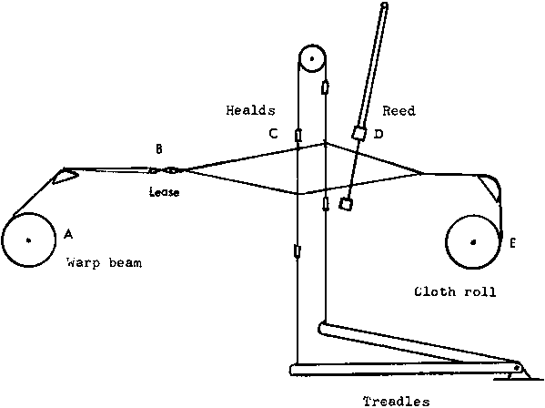Technology is also a part in the production of silk saris. The automated design process has replaced the traditional design process. The image of the motif is first scanned and then it is traced and filled with bitmaps. Finally the image is transferred to the punch cards. These punch cards are given to the weavers if they are working in a cooperative society or under dealers in kancheepuram but if they are running their own business they have to buy their own punch cards. Now the punch cards are attached in the form of a chain and loaded into the jacquard machine to start weaving. This automated process is simple and time saving.

* 1. **Working of a loom**

Two types of looms are used in for the production of Kanchipuram silk saree viz. Frame loom and Pit loom. Throw shuttle is invariably used for the production of saree on the two types of loom. The main parts of the loom are: Sley, Treadles, Reed, Healds, Warp Beam, Cloth beam, Shuttle and Lease rods.

Fig 60 ( Line diagram of a loom ; source: <http://www.tangedco.gov.in/linkpdf/ONE_PAGE_STATEMENT.pdf> )

The warp threads from the beam are drawn through the healds, **C**, threaded through the splits of the reed **D**and at the point **F**interlaced with the weft supplied by the shuttle **S**(throw shuttle). The cloth is formed at the fell of the cloth **F**, and is wound upon the cloth roller situated at the front of the loom **E**after passing through the take up roller**,**which ensures enough tension for winding the cloth. The reed is fixed on the Sley, which moves freely. The treadle operates the healds to form the Shed.

The weaving process itself consists of three basic operations viz. Shedding, Picking and Beat-up which form a continuous cycle in the simple handloom either pit loom or frame loom. The picking and beat up operation are fixed no matter what type of fabric is being produced, but the shedding motion is variable and can be described as the heart of weaving as it is here the nature of interlacing, the weave is decided.

Shedding is the raising of the warp yarns to form a separation through which the weft yarn can be inserted. Simple and intricate shedding operations are performed automatically by the heddle or heald frame, also known as harness. This is a rectangular frame to which a series of wires, called heddles or healds, are attached. The yarns are passed through the eye holes of the heddles, which hang vertically from the harnesses. The weave pattern determines which harness controls which warp yarns, and the number of harnesses used depends on the complexity of the weave. Two common methods of controlling the heddles are dobbies and a jacquard head.As the harness raise the heddles, which raise the warp yarns, the shed is created and the shuttle passes through it. As the shuttle moves across the loom laying down the fill yarn, it also passes through openings in another frame called a reed (which resembles a comb). The point where the fabric is formed is called the fell. With each weaving operation, the newly constructed fabric must be wound on a cloth beam. This process is called taking up. At the same time, the warp yarns yarns must be let off or released from the warp beams.

* 1. **Weaving**

Weaving is done on looms. The weaver interlaces the silk threads of weft and warp. The shuttle passes through the opens formed when the pedal is operated to interlock the threads of warp and the weft. Once the shuttle is passed, the suspended rope from jacquard is pulled to form the weave. The proton of woven cloth is wounded to the wooden beam which is in front of the weaver. After weaving of 6 meters of weft, the portion of unwoven warp is intentionally left before and after the sari weaving which is later knotted for fringe. Thus the weaving is completed; the unwoven stands are cut out with a small metal blade and sari is folded in traditional manner for the marketing.  
  
It takes nearly 10 to 15 days to complete one sari. The length of 10 saris warp is loaded into the loom at a time. The weaver may need 1 or 2 persons help while working.

Fig 61 *(Continuous pedal movement to operate loom: source-self)*

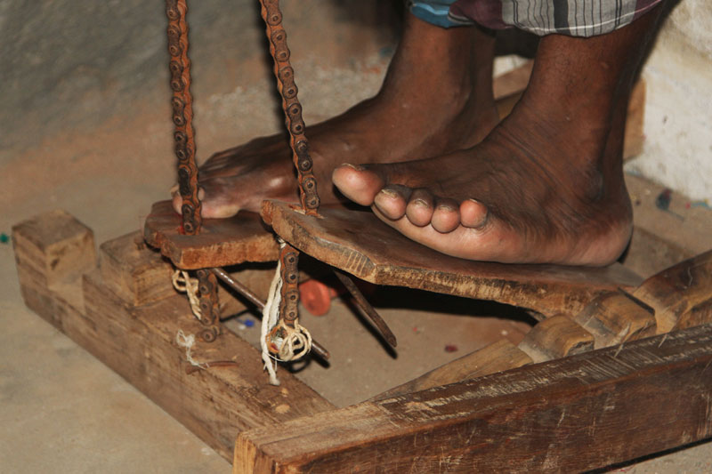

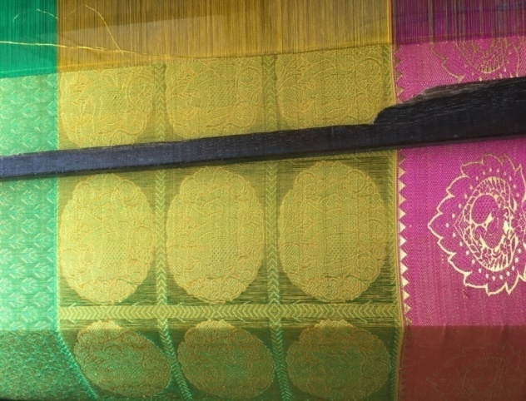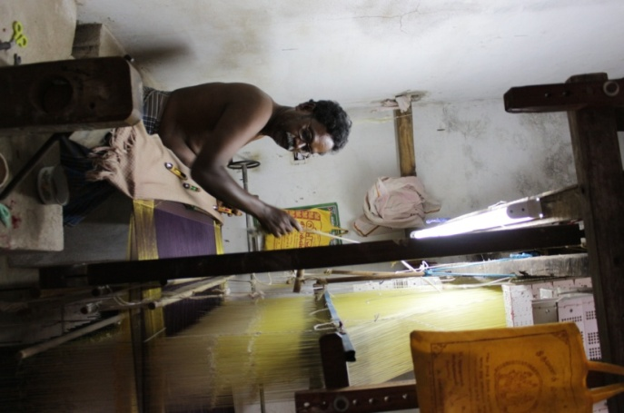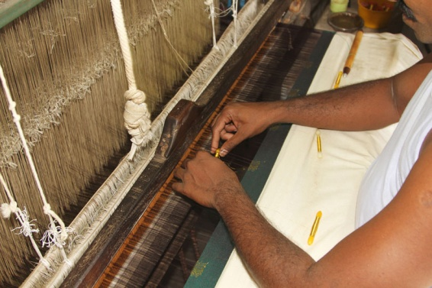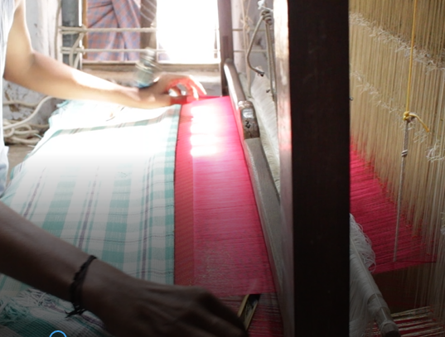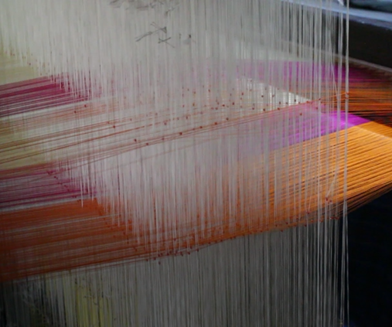

Fig 63 *(Picking: source-self)*

Fig 62 *(Shedding: source-self)*

Fig 64 *(Beating: source-self)*

*Fig.66 ( Fell of the cloth: source-self)*

Fig 65 *(* *External Zari thread is inserted to create motif designs.: source-self)*

# SPECIALITY OF KANCHEEPURAM SAREE

* 1. **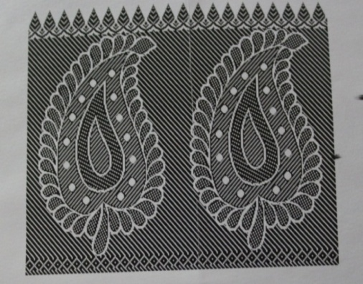Motifs**

The motifs are drawn from the nature and forms of temple architecture like peacock, parrot, temple designs, scenes from Ramayana, Mahabharata, Bhagwad Gita. Few of the best known patterns in Kanchipuram saris are Mayilkann (peacock eye), Kuyilkann (nightingale eye), Rudraksham (Rudraksha beads) and Gopuram (temples).

MANKOLAM / MANGO MOTIF / PAISLEY

*Fig 67 (Paisley pattern given to the weavers; source: self)*

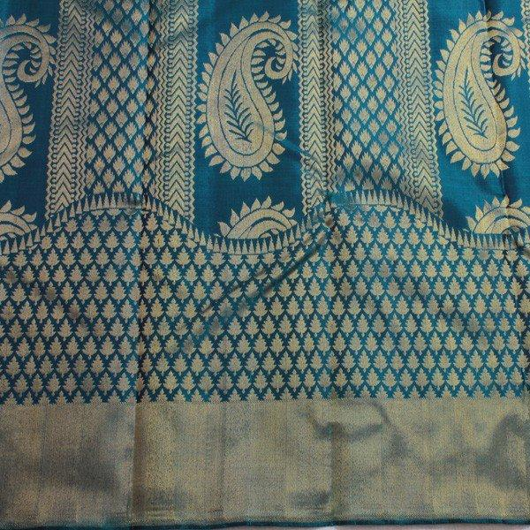This pattern was called “Mankolam” in Tamil & “Boteh Jegheh” in Persian. The “Mankolam” is the mango shaped design that is often associated with the Hindu religion and its mythology. The traditional Paisley’s are  made using the twill tapestry technique whereby the weft threads (horizontals) forming the pattern were woven back and forth around the warp (vertical) threads only where a particular colour is required.

THE RESPLENDENT PEACOCK / ANNAPAKSHI

Being the national bird of India, its beauty is ingrained in every aspect of our culture. This gorgeous creature, a universal symbol of beauty, riches as well as foolish vanity, has also captured the imagination of other civilizations. Artists from Byzantium and ancient Rome derived inspiration from its majestic grace; peacock images can be found in the tomb art of early Christians.

*Fig68 (Paisley Pattern on a saree; source:* ([*https://www.sarangithestore.com/blogs/sari-designs*](https://www.sarangithestore.com/blogs/sari-designs)*)*

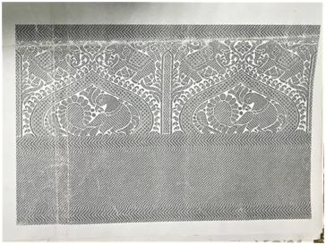In India, peacocks were strongly associated with royalty. Their beautiful feathers were woven into fans for kings, queens and nobles. In religion, the peacock is linked with two deities, *Skanda* and *Krishna. A*rtists typically depicted this bird as an absent lover in miniature paintings. However, the dance of the peacock, with the arrival of dark monsoon clouds, symbolizes courtship in popular culture.

The peacock’s alluring form and luminous colours have made it a timeless motif in Indian textile traditions including Kanjivaram saris. The peacock tail lends itself to myriad stylized depictions – as a

*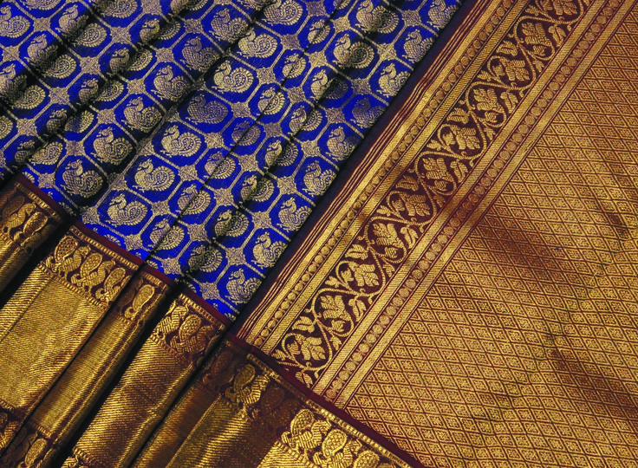*sharp-edged triangle, a sensuously curving paisley or flaring open with hundreds of blue-green ‘eyes’. Plump peacocks strut along  sari borders in golden splendour; two peacocks facing towards or away from each other, enhance the grandeur of a fully worked pallu.

*Fig 69 (Annapakshi pattern given to the weavers; source:self)*

VOLUPTUOUS VINES

The curving beauty of creeper vines has for long inspired textile weavers across India.  From slender, leafy stems to elaborate, stylized motifs embellished with flowers and fruits, vines lend themselves wonderfully to creative expression. Besides its obvious charm, the vine bears a deeper significance, for it represents the Tree of Life.

The Tree of Life is a sacred symbol which appears in folk art and cultures worldwide, a concept that is deeply embedded in humanity’s collective consciousness. Its roots thrust deep into the earth, while its branches spread out and soar up, supporting the heavens. The massive trunk is the connecting link between these worlds.

*Fig 70 (Annapakshi Motif on a saree; source:* [*https://www.sarangithestore.com/blogs/sari-designs*](https://www.sarangithestore.com/blogs/sari-designs) *)*

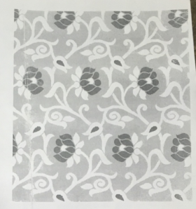 According to Indian tradition, the peepal and banyan symbolize the Tree of Life. While the deep roots of these great trees represent the foundation of all life, the trunk and branches symbolize ancient, spiritually evolved communities, while we, human beings, are the leaves.

In artistic traditions, the Tree of Life is often depicted as a sinuous, multi-branched vine laden heavily with fruit and flowers, often home to a variety of birds and animals, a symbol of limitless abundance, fertility and the cyclical pattern of life.

Kanjivaram saris typically feature profusely flowering vines as symmetrical borders, picked out in zari or rich colours contrasting with the body of the sari. Trailing vines may be woven across the sari field or in complex patterns to embellish an ornate pallu. However they are depicted, vine motifs add grace and an ineffable charm to the feminine form.

*Fig 71 (Vines pattern given to the weaver; source: self)*

*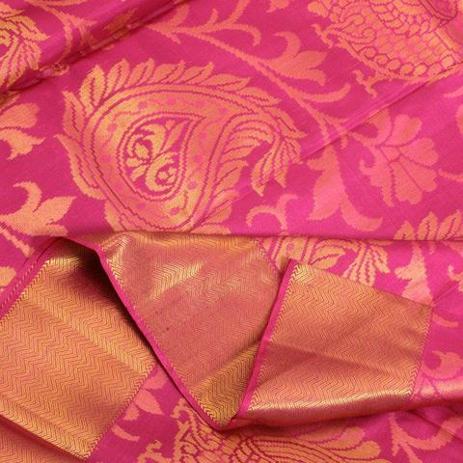*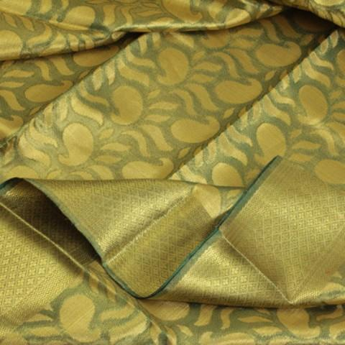*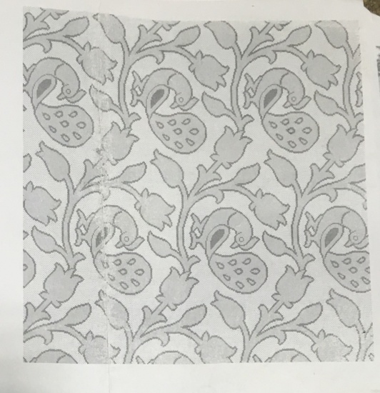*

*Fig 72 (Voluptuous Motif on a saree; source: self)*

*Fig73 (Tree Of Life Motif pattern given to a weaver; source: self)*

*Fig74 (Voluptuous Motif on a saree; source:* [*https://www.sarangithestore.com/blogs/sari-designs*](https://www.sarangithestore.com/blogs/sari-designs)*)*

PADMA

For centuries, the lotus has occupied a significant space in Indian thought, poetry, literature, art, and religions. Padma, as this graceful bloom is termed in Sanskrit, is rich in symbolism. It represents a fundamental principle of Hindu philosophy, that of maintaining purity and detachment through the vicissitudes of life. Rooted in mud and slime, the lotus rises from the darkness of its origins to float under clear skies, its leaves and flowers remaining untouched by water or mud. Ancient philosophers have extolled this natural phenomenon as an ideal to aspire for. In the words of the *Bhagavad-Gita: “One who performs his duty without attachment, surrendering the results unto the Supreme Lord, is unaffected by sinful action, as the lotus leaf is untouched by water.”*

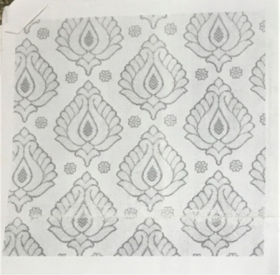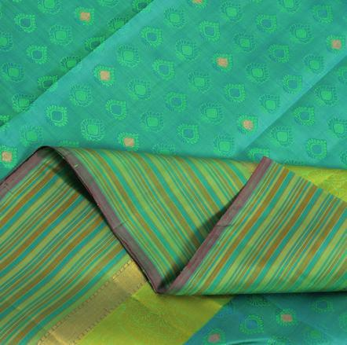In Buddhism, the lotus is one among the eight Auspicious Symbols, its life cycle representing the soul’s journey, from the depths of base materialism to the sunlight of enlightenment.  The *Lalitsvara* says: *"The spirit of the best of men is spotless, like the lotus in the muddy water which does not adhere to it.“*

*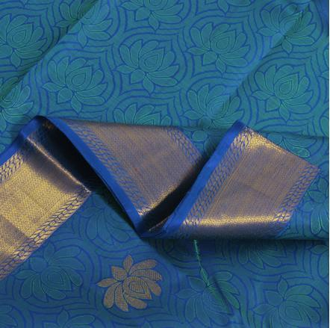*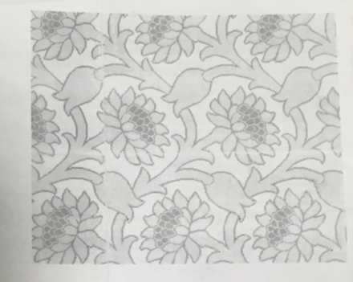

*Fig 78 (Lotus Motif on a saree; source:self)*

*Fig77 (Lotus bud motif on a saree; source: self)*

*Fig 76 (Lotus bud pattern; source: self)*

*Fig 75 (Lotus pattern given to the weaver; source: self)*

YALI – THE BEAUTIFUL BEAST

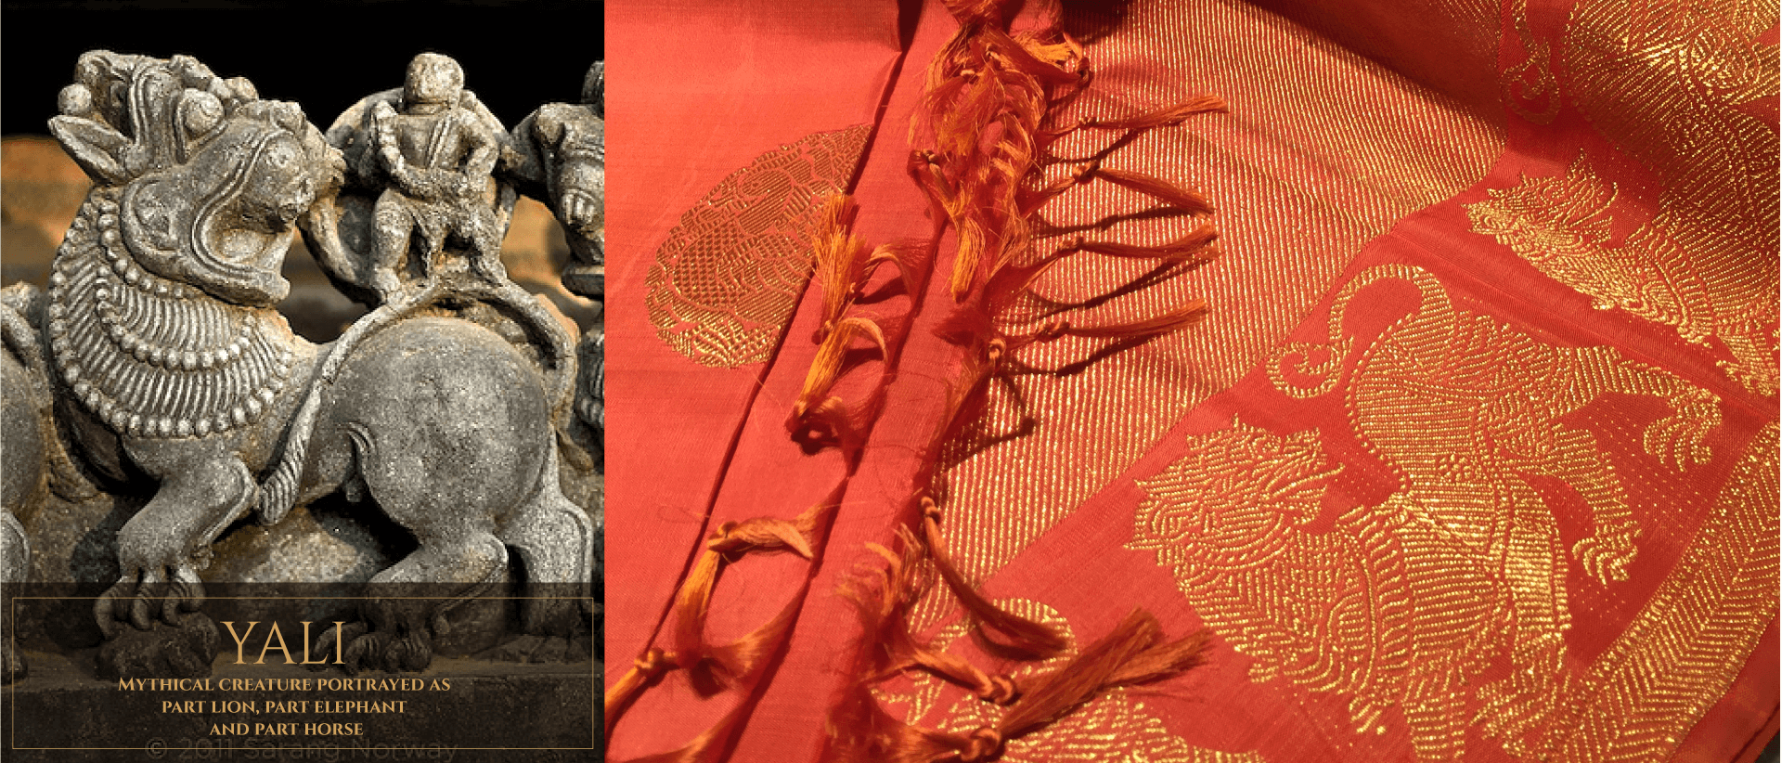In the skilled hands of a Kanjivaram weaver, even the ferocious *Yali*, a mythical beast sculpted on Hindu temple pillars, takes on an appearance of grace and majesty!

*Yali* – leogryph in English – is derived from the Sanskrit word ‘*Vyala’* and means ‘fearsome warrior’. Was the *Yali* the product of a sculptor’s fertile imagination? Possibly, for it is comprised of a lion’s body and head, an elephant trunk & tusks and a serpentine tail. The qualities associated with these animals – ferocity, strength and guile respectively – make the *Yali* a formidable presence on temple entrances and pillars, guarding the sacred space within. *Yalis* are believed to be more powerful than the lion/Tiger or the elephant. The *Yali* assumes other forms too in temple sculptures, the lion’s head replaced with that of a horse, human or dog.

*Fig79 (Yali sculpture; source:* [*https://www.sarangithestore.com/blogs/sari-designs*](https://www.sarangithestore.com/blogs/sari-designs)*)*

*Fig 80 (Yali motif on a saree; source:* [*https://www.sarangithestore.com/blogs/sari-designs*](https://www.sarangithestore.com/blogs/sari-designs)*)*

SACRED CHECKS AND MESMERIZING TRACKS

The humble and universally popular motifs of checks and parallel lines take on a touch of magic when the deft fingers of Kanjivaram weavers translate them onto timelessly beautiful silk saris.  Apart from aesthetics, checkered cloth has a deeper significance, rooted as it is in Hindu thought. The check motif (the word is derived from the Sanskrit ‘chowk’) is in fact a representation of a *mandala*or sacred grid that symbolizes the universe. The horizontally running lines are parallel to the earth while the vertical lines arise from earth and go upwards. The crossing and linking of these lines is thought to create the cosmic energy that is manifest in all of creation.  Tiny micro-checks all over the sari field in alternating colors have a soft, pleasing effect and are usually set off with a relatively simple border. A stunning traditional combination of checks in yellow, red and black has a deeper significance, these colors representing the three *gunas*or essential attributes present in all individuals. Yellow symbolizes *sattvic guna,*the quality of introversion and desire for spiritual progress. Red is *rajas –*passion, joy and desire for power. Black is *tamas –*inertia, indolence and brutishness.

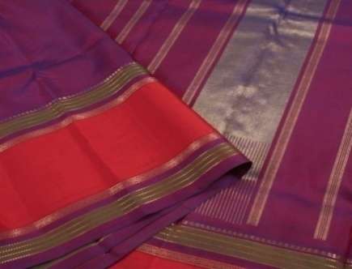Plain stripes running parallel to the sari border are appropriately known as *thandavalam*– the track motif. Woven as zari lines across a plain sari field or in alternating stripes of colors that contrast or complement each other, this simple, abstract design, when draped, accentuates the graceful curves of the feminine form.

*Fig 82 ( Thandavalam on a saree; source:* [*https://www.sarangithestore.com/blogs/sari-designs*](https://www.sarangithestore.com/blogs/sari-designs)*)*

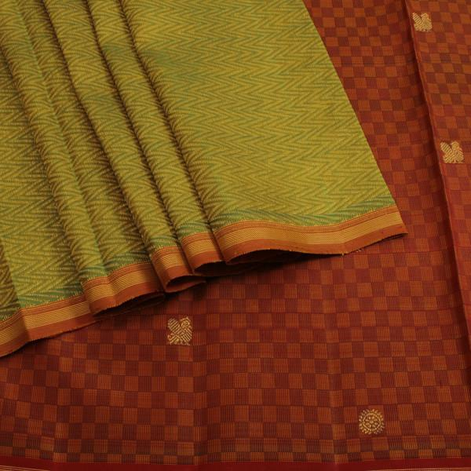

*Fig 81 (Checks on a saree; source:* [*https://www.sarangithestore.com/blogs/sari-designs*](https://www.sarangithestore.com/blogs/sari-designs)*)*

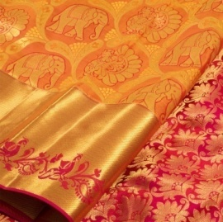ELEPHANT / YAANAI

The elephant, gentle giant among animals, occupies prime position in Indian thought, culture and mythology. Vedic poets eulogized its enormous strength. Its huge size and grey color were associated with rain-bearing clouds that brought relief to land parched by the sun. Ganesha, the elephant-headed son of Shiva and Parvati is an adored household deity. In truth, it is not so much the animal that is worshipped as its qualities of wisdom, loyalty and spiritual insight.

Kanjivaram’s weavers have long celebrated the beloved pachyderm’s contrasting attributes – a bulky frame and gracefully waving trunk – with elephant motifs on their splendid silk saris. From a row of tiny elephants trumpeting in unison along a sari border to motifs scattered across the sari field, this is one symbol that never goes out of style.

*Fig 83 ( Elephant motif on a saree; source:* [*https://www.sarangithestore.com/blogs/sari-designs*](https://www.sarangithestore.com/blogs/sari-designs)*)*

*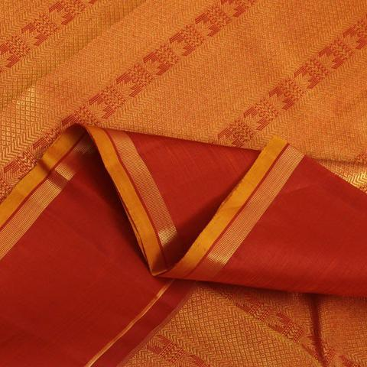*

PEACOCK’S EYE / MAYILKANN

*Mayilkann*or ‘peacock’s eye’ is among the oldest of Kanjivaram motifs, one that‘s associated with many Hindu gods and legends. Indra, leader of the Devas, once hid under a peacock’s wing from the demon Ravana and in gratitude, is said to have bestowed the bird with 1000 eyes on its tail. Another myth has it that the sun-god Surya’s daughter fell in love with the peacock. When the vain and foolish bird paid little heed to his besotted wife, Surya banished him to earth. His daughter’s tears, falling from heaven, became ‘eyes’ on the peacock’s tail. Kanjivaram’s weavers typically feature *mayilkann* motifs woven closely together across the body, pallu or along sari borders. The glittering ‘eyes’ bring alive a timeless tradition of elegance on a Kanjivaram Silk Sari.

*Fig 84 (Peacock’s eye motif on a saree; source:* [*https://www.sarangithestore.com/blogs/sari-designs*](https://www.sarangithestore.com/blogs/sari-designs)*)*

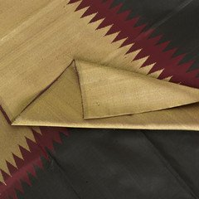BORDERED IN BEAUTY

The beauty and distinguishing element of a Kanjivaram often comes from its border. The type of border that one wants in the sari often dictates the choice of sari. The amount of zari, the motifs used, the space between motifs, the choice of contrasting colours, the width or height of the border – all these go into determining the final look of the sari’s border.

**The Rising Borders:**This type of border literally rises along the length of the sari to ascend upward and around the wearer’s body. While this rising border has been present in our Kanjivaram weaves for a long time, it earned the nickname of “Airline” border keeping in mind that the rising border is like a aircraft taking off into the skies. You can wear saris with this border to accentuate your height.

*Fig 85 (Temple Border on a saree; source:* [*https://www.sarangithestore.com/blogs/sari-designs*](https://www.sarangithestore.com/blogs/sari-designs)*)*

**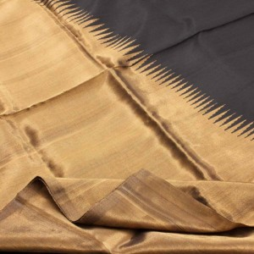**

**Temple Borders:** The ‘temple border’ is usually featured as a stylized row of triangles with serrated edges, their bases resting on the upper edge of a broad sari border. Woven with zari or in thread of a brightly contrasting shade, the *gopurams* rise against the plain backdrop of the sari – simple, yet dramatic and eye-catching!

Usually recommended for women who enjoy the advantage of height, Kanjivarams with tall temple borders are ever popular. The temple has been one of the very popular motifs while designing saris with tall borders. The form of the temple easily lends itself to greater height while the spike of the temple spire is an inspiration for creating beautiful patterns across the body of the sari.

*Fig 86 (Rising Border on a saree; source:* [*https://www.sarangithestore.com/blogs/sari-designs*](https://www.sarangithestore.com/blogs/sari-designs)*)*

*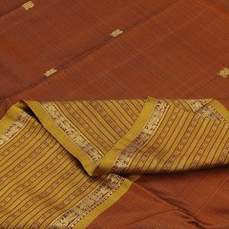***Rudraksh Borders:** Yet another well loved tall border uses the rudraksh motif in multiple lines that run all along the border, creating a beautiful pattern for a lovely visual impact. Tall borders are usually kept to one side of the sari so that when draped, the overall impact in the front is striking and elegant.

Fig 87 (Rudraksh Border on a saree ; source: [*https://www.sarangithestore.com/blogs/sari-designs*](https://www.sarangithestore.com/blogs/sari-designs))

* 1. **Border and Pallu**

**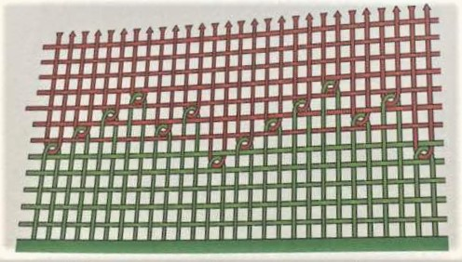**The speciality of Kanceepuram silk saree is contrast border with Korvai technique and contrast pallu with Petni technique. Contrast border is woven using three shuttles, two shuttles for both side border and one shuttle for body of the saree. Contrast Pallu is woven using Petni technique.

The contrast borders and pallus are achieved by Petni & Korvai technique.

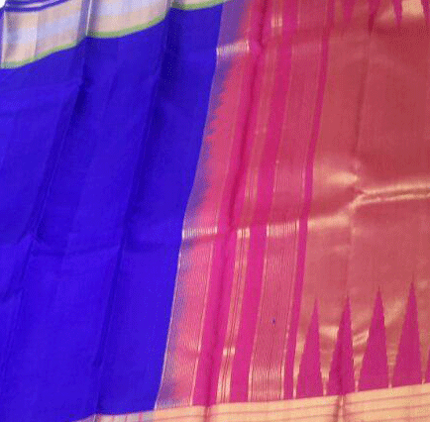**Korvai**: is the technique of joining the border to body of the saree [Single/ double sided border]. This techniques requires additional manpower, which generally fulfilled by employing household labourer. More clearly, few ends of body portion of the warp on both sides are interlaced with the border ends resulting as thick diligent stitch, which portion. In order to achieve this effect, three shuttles are used, two are handled by the weaver concerned and the third one is handled by the household labourer. Since this process requires additional labourer, who has to synchronize his activity of weft insertion with the experienced weaver, results in enormous delay.

*Fig.90 (Petni of a Kancheepuram saree: source-Silk Sarees of Tamil Nadu By Nesa Arumugam)*

*Fig.88 (Korvai Technique of making a Kancheepuram saree: source-Silk Sarees of Tamil Nadu By Nesa Arumugam)*

**Petni:** process, which is nothing but mending the Pallu portion of warp with the existing portion of the body in each saree. This involves mending of all the warp threads in the body portion of the saree, which counts to few thousand.

The contrast yarn is laid over the body of the warp. The new contrast warp is held firmly and then the weaver weaves an inch or two, beating the weft firmly. After another inch or two of weaving and the weft beaten down firmly, the old warp is cut and the weaver continues weaving the contrast pallu.

# COSTING

**RAW MATERIALS**

Cost of pure silk is Rs. 4,250 per kg and of blended silk is Rs. 1,300 per kg.

The cost for dyeing is according to the weight of silk. For dyeing 1kg silk yarn the price is Rs.200.

Cost of brass zari for 1 saree is Rs.2000 (1 gram is 6 rupees)

Cost of gold zari for 3 sarees is Rs. 25,000 (one bobbin of gold zari).

Zari is sold in a measure called Marc, one marc being 242 grams of gold. Theoretically1

Marc of pure zari should contain 55% - 57% silver and 0.6% gold.

Cost of one punch card for a medium level design is Rs.6000

**LABOUR WAGE**

COTTON SAREE- The time taken to complete one saree is 3 ½ hours.

SILK SAREE - The time taken to complete a silk saree with a handloom is 7 days.

LUNGI - The time taken to complete one lungi is 2 hours.

* UNDER GOVERNMENT

The wages vary from Rs.150 – 250 per day.

COTTON SAREE- They get a daily wage of Rs.140.

SILK SAREE - They get a daily wage of Rs. 200.

LUNGI - They get a daily wage of Rs. 480 for weaving 200 m of lungi.

* UNDER PRIVATE AGENT

The wages vary from Rs.170 – 240 per day. If working under a head weaver, they are paid a daily wage of Rs.140.

COTTON SAREE- They get a daily wage of Rs. 170.

SILK SAREE - They get a daily wage of Rs. 180.

* SELF

Per meter of saree they are paid Rs. 35-45.

COTTON SAREE- They get a daily wage of Rs 220.

SILK SAREE - They get a daily wage of Rs. 300.

PILLAYAAR THUNDU – They get a daily wage of Rs. 150.

**FINISHED PRODUCT COST**

ORIGINAL SILK SAREE – Rs.30, 000 – 1,00,000 and more

DUPLICATE SILK SAREE – Rs. 8000.

COTTON SAREE – Rs. 250 – 1000.

# PROBLEMS AND ISSUES FACED BY PEOPLE IN THIRUMALPUR

* 1. **Financial Problem:**

Almost 99% of the population of Thirumalpur is involved in weaving industry. Most of them take orders from co-operative society and few of them are connected with private retailers in Kancheepuram but the livelihood conditions are same in both the cases. They are not economically strong like middlemen or retailers involved in this business because they are not directly connected to customer. They get only little profit after spending so much time and money. They told that sometimes they must takes loans from bank because of loss in previous year. According to them, the cost of raw material is increasing day by day but they get the same profit as they use to get in previous years so they are going in loss. But from this year, they increased the price of their products.

* 1. **Health Problems:**

People have no choice but to go to Kancheepuram for the smallest health issues. Most of the weaver suffer from eyesight problem, back-pain problem, leg ache problem and other joint pain problems due continues hard work.

The village lack health facilities. They do not have any private or government hospital though they have one government veterinary hospital.

* 1. **Education:**

Thirumalpur has a government school, but parents prefer sending their children to private schools for better education which is quite expensive. The government school is short of staff. Teachers are not able to come on time as they have to travel to reach the village.

* 1. **Scope for Learning:**

Weavers living in Thirumalpur have very less opportunity of learning. There is only one training institute where they can go and learn how to make new design and pattern. Most of the people are not trained and can’t make new design which reduce their chances of sale and affect their economic condition. They only make few patterns which they learnt from their ancestors and the other weavers who got trained can make different patterns so their sales are higher than them.

* 1. **Job Opportunities in Thirumalpur**

Most people in Thirumalpur have weaving as their occupation and the rest practice agriculture, most of the youth work in different cities because of lack of job opportunities and also because weaving fetches very little profits for them.

* 1. **Problems in Weaving Profession:**

**1. Rising input costs**: The prices of yarn, dyes, chemicals, and other inputs have increased sharply in the recent period. This has resulted into cost disadvantage to the weavers. The problem is more acute for the individual weavers who need small quantities of yarn and chemicals. This situation is affecting the level of output in the handloom industry.

**2. Lack of modernization**: The handloom industry has been using age old technology and looms. These results into low productivity and high cost. Again, the continuous and repetitive movements of production process adversely affect the speed of production.

**3. Migration to other fields:** Due to the lower income and instable work the younger generation of weavers has been migrating to other occupations. This has reduced the weaver community.

**4. Inadequate research and development:** Due to the vulnerable financial condition, the weavers, individually, are not able to set research and development facility and spend money on it. The state provisions are also not sufficient. Modern designs are not developed in sufficient number and in tune with the changing taste of the public.

**5. Inadequate training:** The existing training and skill development programs are not sufficient to train the weavers. Also, there is need to install new and updated machinery. More financial and faculty support be provided to the handloom training institutes and weaver service centers.

# FINANCIAL AID

The weavers take loans if they want to upgrade their machines or if their children are getting married. They take loans from Canara Bank.There are about 300 loans taken as of March 2017. **Interest Subvention:** The interest rate on loans is 10.05% but it is reduced to 6% as the government gives 4% of the loan.

* 1. **Weavers Credit Card Scheme**

It aims to provide easy access to financing for weavers. With majority of the industry still being unorganized and filled with micro businesses, the government has introduced a specialized scheme for financing weavers and workers.

**Overview**: Financing is provided for purchase of tools and equipments required for carrying out weaving activity and working capital requirement. All weavers are eligible for loan under this scheme.

**Amount of Loan:** Existing weavers having photo identification card is a necessary pre-condition for availing the weavers credit card. A maximum of Rs. 2 lakhs is provided as a term loan or cash credit facility under this scheme.

**Interest and Repayment:** The rate of interest on weavers credit card is linked to the bank base rate. No Margin is required up to a loan of Rs 25000/- but Rs 25000/- a 20% Margin is required.

**Benefits:** No collateral security is required

* 1. **MSME Loan**

A 25,000 loan is provided to buy the loom. There is no subsidy for this loan.

* 1. **Pradhan Mantri Mudra Yojana**

**Objective:** To fund the unfunded units which are existing outside the formal banking fold and are unable to sustain or grow due to lack of finance or relying on informal channels ,which are expensive or unreliable by bringing such enterprises to the formal financial system and extending affordable credit to them.

**Purpose:** For setting up of new/upgrading existing Micro business enterprises in the manufacturing, processing, trading and service sector and carrying out  activities allied to agriculture, financing to weavers and artisans.

**Nature of facility**: Term Loan and/or Working Capital minimum of Rs.50,000 and up to Rs.2 lakhs

**Collateral Security :**  NIL

* 1. **Agricultural Loan**

Agricultural loan is also available. Loan can be taken against gold.

# IMG_6089.JPGSOCIAL CONDITION

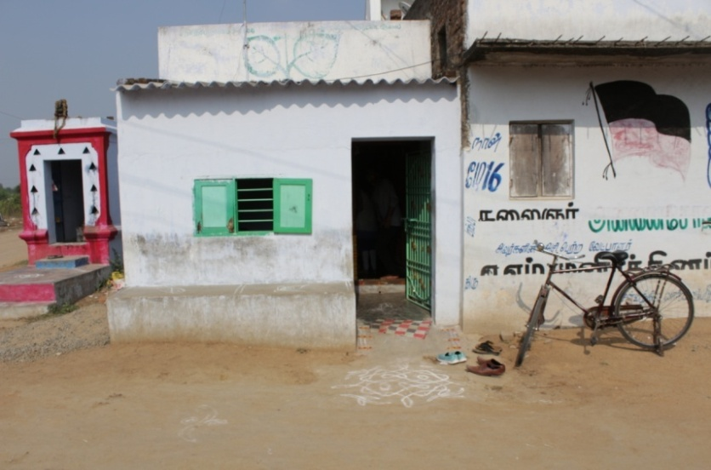The living standard of weavers in Thirumalpur is not particularly good because of their meager incomes. They are able to earn just enough to satisfy their basic necessities. Though the weavers are uneducated every one of them ensures that their children gets proper education so that their children don’t have to end up in their ancestral weaving business which involves tremendous time and effort but doesn’t get them that much income. There is hardly any population between the age of 20-30 as they have gone out for further education or a job. They are able to earn much more than how much their parents were able to through their weaving business. This is lifting their economic condition and their living standard. We came across a 25-year-old man, Antari, son of a farmer who couldn’t earn from than 20,000-25,000. But he studied in the government college at the village and got a diploma in Electronic Communication and started working in the Testing and communication department in Quatar. He earnt much more than he could through farming and was able to provide his family a better living. His brother was a Civil Engineer and worked in Kancheepuram and his wife a B.Sc lab technician. Truly, education helped improve their social status and their income as well.

*Fig.92 (cooking utensils in their house: source-self)*

The weavers are able to save upto 1000 rupees each month from the 10,000 rupees they earn every month. Almost each one of them has taken a loan from the bank at one point or the other in their life, be it for buying raw materials, for a marriage, upgrading their machine or building their house. The houses of the weavers were very small. One room had the loom and other equipments where most of them had installed a television set. The TV’s were nearly 22 years old. They did not have any proper tiles, most of them had a cemented ground.

*Fig.93 House of an independent weaver; source:self*

We met Mr. Kumar who worked independently. He bought his own raw materials and even sold the sarees on his own. He even made his own designs. He bought white silk from Kamachi Store in Kancheepuram and gave it to another person to dye the yarn according to his needs. He did not have enough money to put his son in a private school but he did put him in the private school for the sake of prestige. Nevertheless, even he was sure of not letting his son join the weaving business. He earned comparatively more money than weavers who worked in a cooperative society or under a middleman. His monthly income was Rs 24,000- Rs 25,000 and expenses were Rs10,000.

Next we had an opportunity to speak to Mr. Kandhirvel and Mrs. Krishnaveni. Mr. Kandhirvel had been weaving for 35 years. His father was a farmer and his grandfather was a weaver, from whom he learnt weaving. He was not a part of the cooperative society, he took orders from a middleman in Kancheepuram. He is provided with raw materials, design and punchcards and is paid once he completes the saree.It takes him 10-15 days to weave one saree and his profit per saree is Rs2800. He did not know how to use a powerloom and hence used handloom. He had to travel all the way to Amjikarai to meet his doctor, ‘Dr. Balaji’ for his health problems. Their son studied in the government school and then Pallava college from where he got a EEE degree. Then he joined a job in VolTech, Chennai. They travelled to Chennai regularlyto meet their son.

Then we spoke to Mr. PA Arul who was a part of the cooperative society. He had taken a loan from the bank last year to build his own house. His son failed in 10th after which he joined the weaving business with his father. He continued weaving for 6 years but when he saw that the industry was dying he decided to study. After 6 years of working as a weaver he wrote his 10th exams, passed from school, graduated as EEE Engineer and got a job at VolTech, Banglore.

Mr. Vengova told us about how the weaving industry was going in loss. He used to buy new clothes for his family on Pongal every year but this year they couldn’t due to financial loss. For the first time he tried weaving a saree with elephant motif. It took around 20 days to weave the saree. It required higher skill and he was doing it for the first time. The middleman had taught him as to how to weave the saree. He took this challenge of weaving a tougher saree expecting higher income.

# SWOT ANALYSIS

1. **STRENGTH**

1. **Raw material base:** India has high self sufficiency for raw material particularly natural fibres.
2. **Flexibility:** The small size of weaving industry allows for greater flexibility to service smaller and specialized orders.
3. **Rich Heritage:** The cultural diversity and rich heritage of the country offers good inspiration base for designs.
4. **Domestic market:** Natural demand drivers including rising income levels, increasing urbanisation and growth of the purchasing population drive domestic demand.
5. **Finance:** Existence of bankers.

Good Government support.

1. **Production:** Availability of skilled weavers.

Good raw material basis.

2. **WEAKNESS**

1. **Weaving Sector:** Thirumalpur has no shuttle-less loom.

Less attention on man power training

Distance of the potential market

Free sarees whose orders are given to the weaver of the cooperative society are a drawback as they kill the creativity of the weavers

1. **Finance:** Low profitability & margins of weavers and which result in bankers being worry supporting of small units. Weavers largely do not come together for bulk purchase of inputs as to benefit from quantity discounts.
2. **Market:** Inadequate attempt to value added products.

Non-adoption of innovative designs in keeping with changing market expectations.

Depending on Government support by co-operative societies.

Unavailability and use of internet facility for forecasting fashion trends and colour schemes.

1. **Product:** Narrow product range.

3. **OPPORTUNITIES**

1. **Integration of Information technology**
2. **Opportunity in High Value Items**
3. **Market:** Participation in trade fairs and buyers and sellers meets.

Common product display centre.

Duty exemption on handloom garments will give scope to capture new market share by introducing new ...products and ready to wear items.

1. **Production:** Common raw material purchase to reduce costs.

Scope for diversification into value added products.

Scope for training.

Brand building.

4. **THREATS**

1. **Decreasing Fashion Cycle:** There has been an increase in seasons per year which has resulted in shortening of the fashion cycle.
2. **Finance:** Bankers may not support development plans of small scale weavers
3. **Market:** Saturated market.

Decline in demand of sarees.

Increase in demand of value added products.

# FUTURE

13 e-commerce entities have partnered with the Office of the Development Commissioner (Handlooms) so far to market handloom products.

You can order a Kancheepuram silk, Mangalgiri cotton or Coimbatore silk cotton saree online. And when you do so, there is a good chance now that the fabric could come directly from the weavers.

Since the introduction of the policy framework by the Centre in August 2015 to promote e-marketing of handloom products, 13 e-commerce entities have partnered with the Office of the Development Commissioner (Handlooms) to market handloom products from specific handloom clusters across the country.

In the last one year, these companies registered sales of Rs.1.7 crore. Some portals work in one or two clusters and some with even three or four. E-commerce entities that are interested can submit an application to the office of the Development Commissioner. They need to have a separate space in the portal to sell the products that are woven in the select clusters. The products have the Handloom Mark or the India Handloom Brand.

On taking weavers to digital commerce, Puneet Gupta, category leader, Apparel, Amazon Fashion, said the Crafted in India store, launched by Amazon in October 2015, already has over 4,000 products listed, which includes sarees, jewellery, and footwear. Co-operatives, master weavers, and sellers of authentic handloom selection are part of the platform. The company’s director and general manager, Seller Services, Gopal Pillai, said Amazon educates, trains, and enables the co-operatives and weavers in these states to sell their products directly. The weavers are introduced to the Internet and they are encouraged to learn more about returns.

This is a big step towards protecting the Handlooms in Kancheepuram but is not yet present in Thirumalpur. It solves the problem of weavers earning less money because of the middlemen. If the e-commerce websites connect with weavers at Thirumalpur then it will increase the incomes of weavers considerably, thus providing them a better lifestyle and ensure that they encourage their children to join the weaving profession.

# CONCLUSION

It is a cliché to say that all that glitters is not gold, but one has to go beyond the beauty of Kanjeevaram silk sarees and take a peek at the reality! As oppose to the glitz and perfect lighting of the silk showrooms, weavers' houses are old and gloomy.

The unique skill of making a Kancheepuram saree was learnt hereditarily from their ancestors. The art of weaving is passed on by way of vision and practice. But the art is now dying because the new generation is not interested in this profession due to the low wages prevailing in the industry.

Thus, it is necessary to have a rehabilitation package similar to the package, which was offered by the government to the farmers, who have lost crops, is provided, and then only the industry can survive.

There was a time when Kancheepuram sarees enjoyed huge popularity as the most suitable saree for any auspicious occasion. As time passed by, the saree started facing tremendous competition from synthetic sarees. Computerization had to be introduced to save the industry from collapse. Today, the quality, style and design of Kancheepuram sarees have got a boost with computer-aided design. The process of design has undergone an unprecedented change. Though the techniques and materials are changing with customers’ tastes and preferences, the motifs are still the same, holding intact the custom and tradition of Kancheepuram sarees.

We must say that our love, respect and appreciation for weaves grew when we learned how these fabrics are made. Theses sarees come from some serious hard work. This is a tradition that deserves respect and preservation. Previously Kancheepuram sarees were more of a style statement for us but now this project has taken us close to the cause of keeping this tradition alive.

# REFERENCES

* Dr. R. Jayavel, (2013, April 3). *Blow of textile industry on member weavers’ of silk handloom co-operative societies in kanchipuram district.* Retrived from http://indianresearchjournals.com/pdf/APJMMR/2013/April/3.pdf
* K.K.S.S.R.Ramachandran, (2014, December). *Handlooms and textiles*. Retrived from http://cms.tn.gov.in/sites/default/files/documents/HHTK\_handlooms\_textiles\_0\_0.pdf
* Press Information Bureau, ( 2016, June 29), *Mudra scheme for handloom sector.* Retrived from http://pib.nic.in/newsite/PrintRelease.aspx?relid=146603
* *Revised Tariff rates with effect from 23.05.2016 payable by the Consumer,* (2014, December 11). Retrieved from http://www.tangedco.gov.in/linkpdf/ONE\_PAGE\_STATEMENT.pdf
* *Thirumalpur Handlooms* (n.d.) retrived from http://handloomcluster-wsc-sz.in/Tirumalpur/activities.htm
* *The Geographical Indication Of Goods Act, 1999 (2004, October 6).* Retrived from http://ipindiaservices.gov.in/GI\_DOC/15/15%20-%20Form%20GI-1%20-%2007-10-2004.pdf
* M. Soundariya, (2016, August 3). *Now, order your Kancheepuram sarees online straight from weavers.* Retrived from http://www.thehindu.com/business/Industry/Now-order-your-Kancheepuram-sarees-online-straight-from-weavers/article14549114.ece
* B. Bowonder and JV Sailesh. (2016, March 17). *A case study of Kancheepuram Silk Saree.* Retrived from http://planningcommission.nic.in/reports/sereport/ser/stdy\_ict/7\_kanchee.pdf

# ANNEXURE 1: Questionnaire

QUESTIONAIRE:

1. What is your name?
2. What is your educational qualification?
3. What religion do you follow?
4. What mode of transportation do you use?
5. Do you pay any taxes?
6. Have you taken loans from the bank?
7. Do you like weaving? Do you want your children to join this profession?
8. For how many years have you been weaving?
9. What are the products you make?
10. How are the working conditions?
11. Who all in the family contribute in the weaving process?
12. Have you undergone any training? Where?
13. What are the raw materials you use, it’s cost and how do you prepare it?
14. Is the input stable and how often do you buy raw materials?
15. How do you dye the yarn?
16. What is the process of making a saree?
17. What is the price range of the saree you make?
18. What are the common mistakes and how do you correct it?
19. What are the specialties of Kancheepuram saree, especially border and pallu?
20. What types of motifs do you use in the sarees?
21. Have the motifs changed or are they the same traditional motifs?
22. Do you connect directly with the customer?
23. What is the sales pattern?
24. Where do you dispose the waste?
25. Do you take any innovative steps in your work?
26. What are the Health problems you face?
27. Have you undergone any training under the cooperative society?
28. What is the role of cooperative society in your life?
29. What challenges are you facing in continuing weaving?
30. What is your income?
31. Do you use your mobile phone to buy and sell items online?